**MEDICAL INVENTORY MANAGEMENT**

**College Name: UNITED COLLEGE OF ARTS AND SCIENCE**

**College Code: bubrl**

**TEAM ID: NM2025TMID27719**

**TEAM MEMBERS:**

**Team LeaderName:**SANTHIYA P

**Email:** santhiyap705@gmail.com

**Team Member1:** RAMYA S

**Email:**  ramyasenthil2k005@gmail.com

**Team Member:**  SAKTHIVEL P

**Email:**  sakthivelpemks@gmail.com

**Team Member:** SANJEEVKUMAR P

**Email:**  sanjuh0853@gmail.com

**1.INTRODUCTION**

**1 Project Overview**

This project is a comprehensive Salesforce application to streamline and manage various operational aspects of medical inventory. The system aims to efficiently maintain supplier details, manage purchase orders, track product details and transactions, and monitor the expiry dates of products. Maintain detailed records of suppliers, including contact information. Catalog product information, including descriptions, stock levels. Monitor and track product expiry dates to avoid using expired items. Comprehensive reports to track supplier performance, and purchase orders.

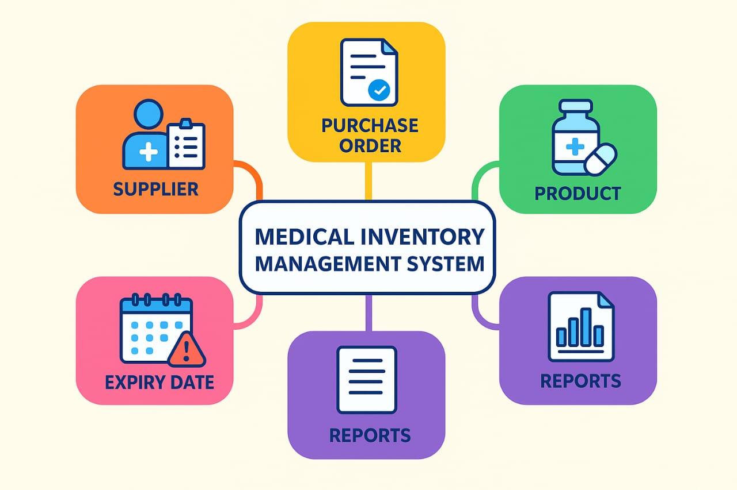

**2. Purpose**

The purpose of the **Medical Inventory Management System** is to design and implement a centralized Salesforce application that streamlines the management of medical inventory. The project aims to solve common challenges faced in healthcare organizations such as manual tracking of suppliers, stock mismanagement, and risks of using expired products.

**DEVELOPMENT PHASE**

**Creating Developer Account:**

By using this URL [**- https://www.salesforce.c**](https://www.salesforce.com/form/developer-signup/?d=pb)

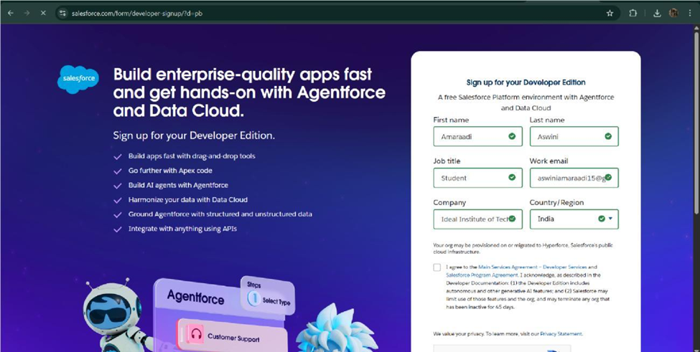

* **Create objects: product, Purchase Order, Order Item, inventory and supplier**

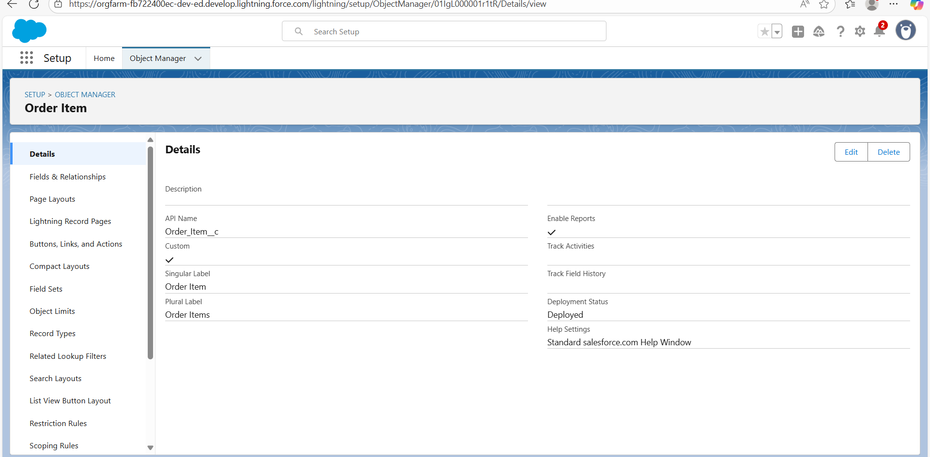

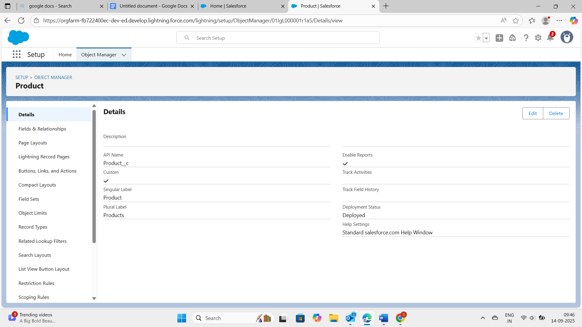

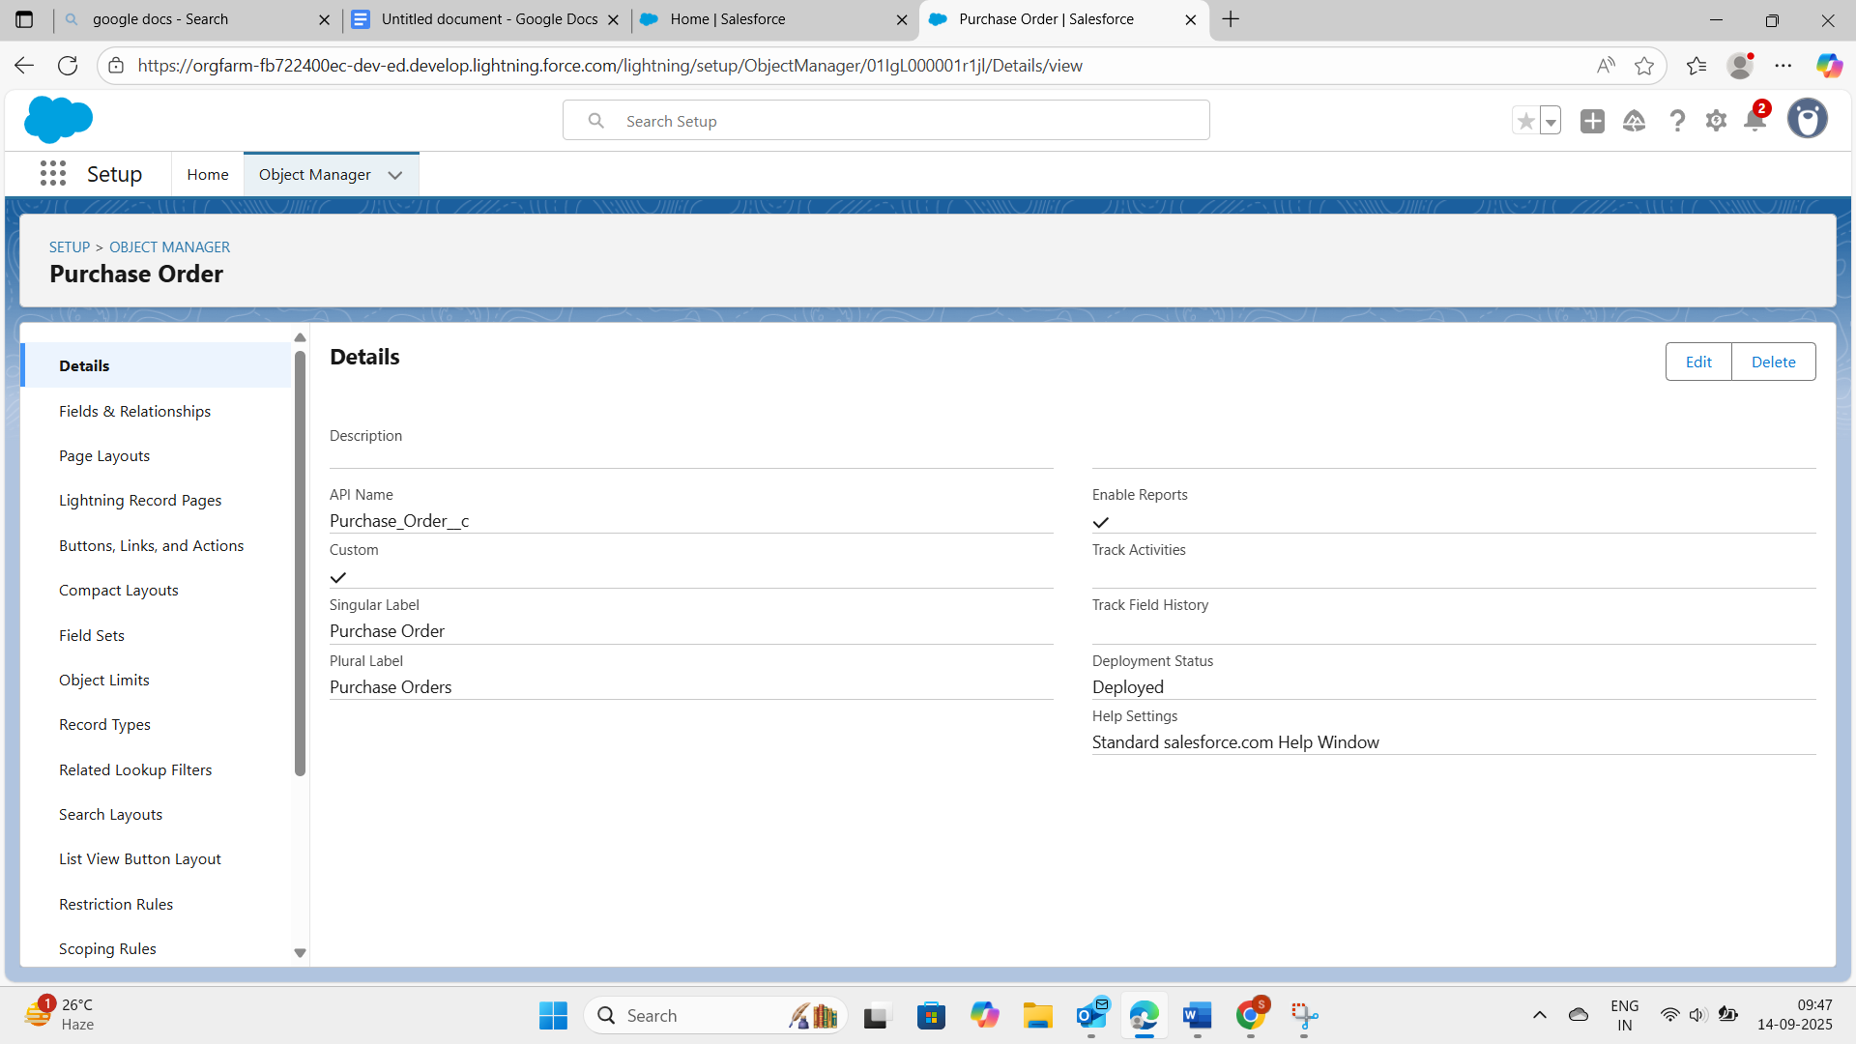

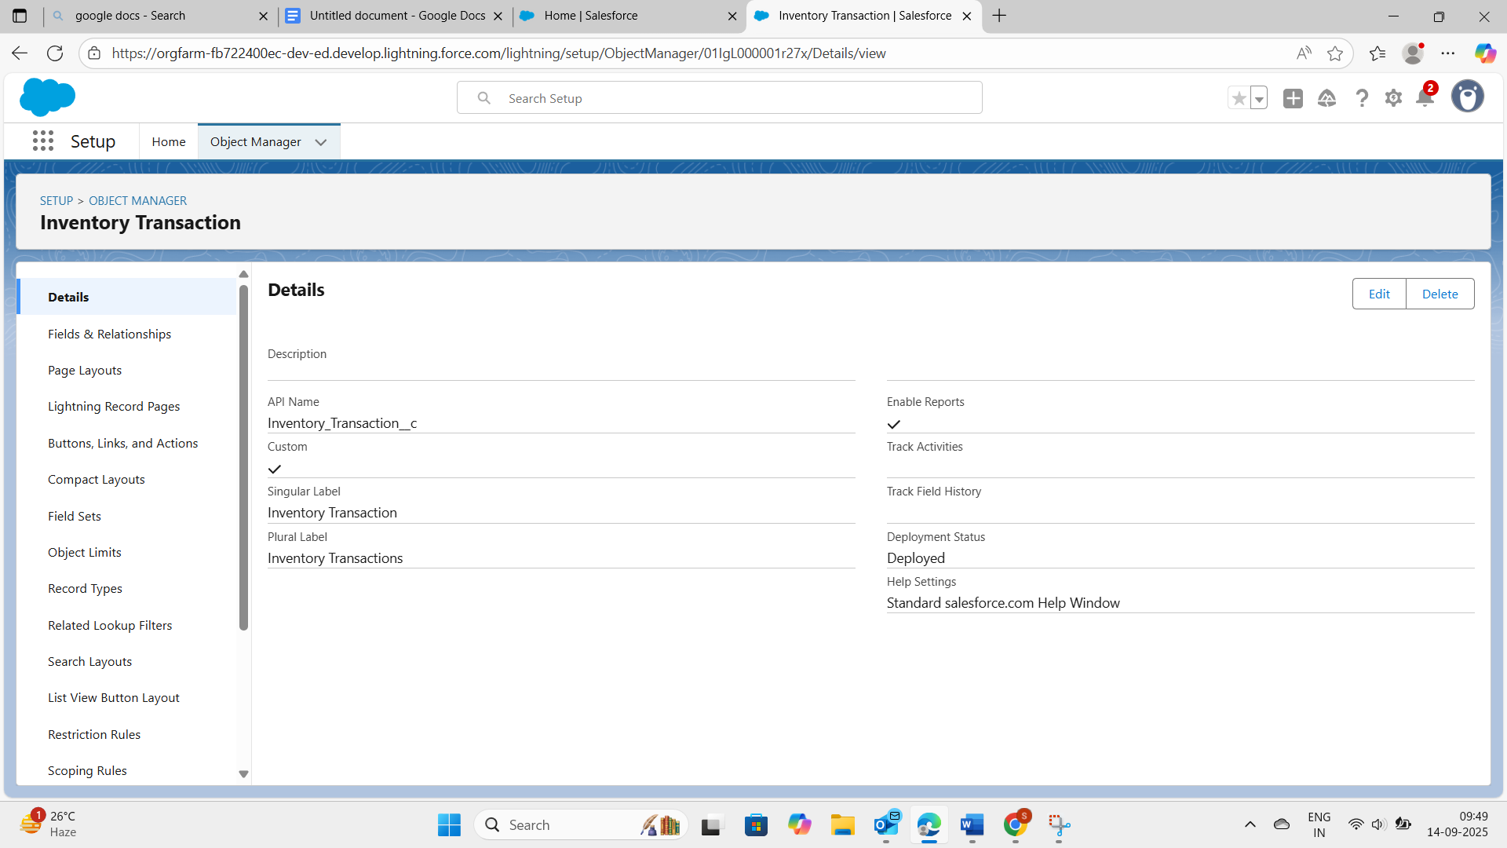

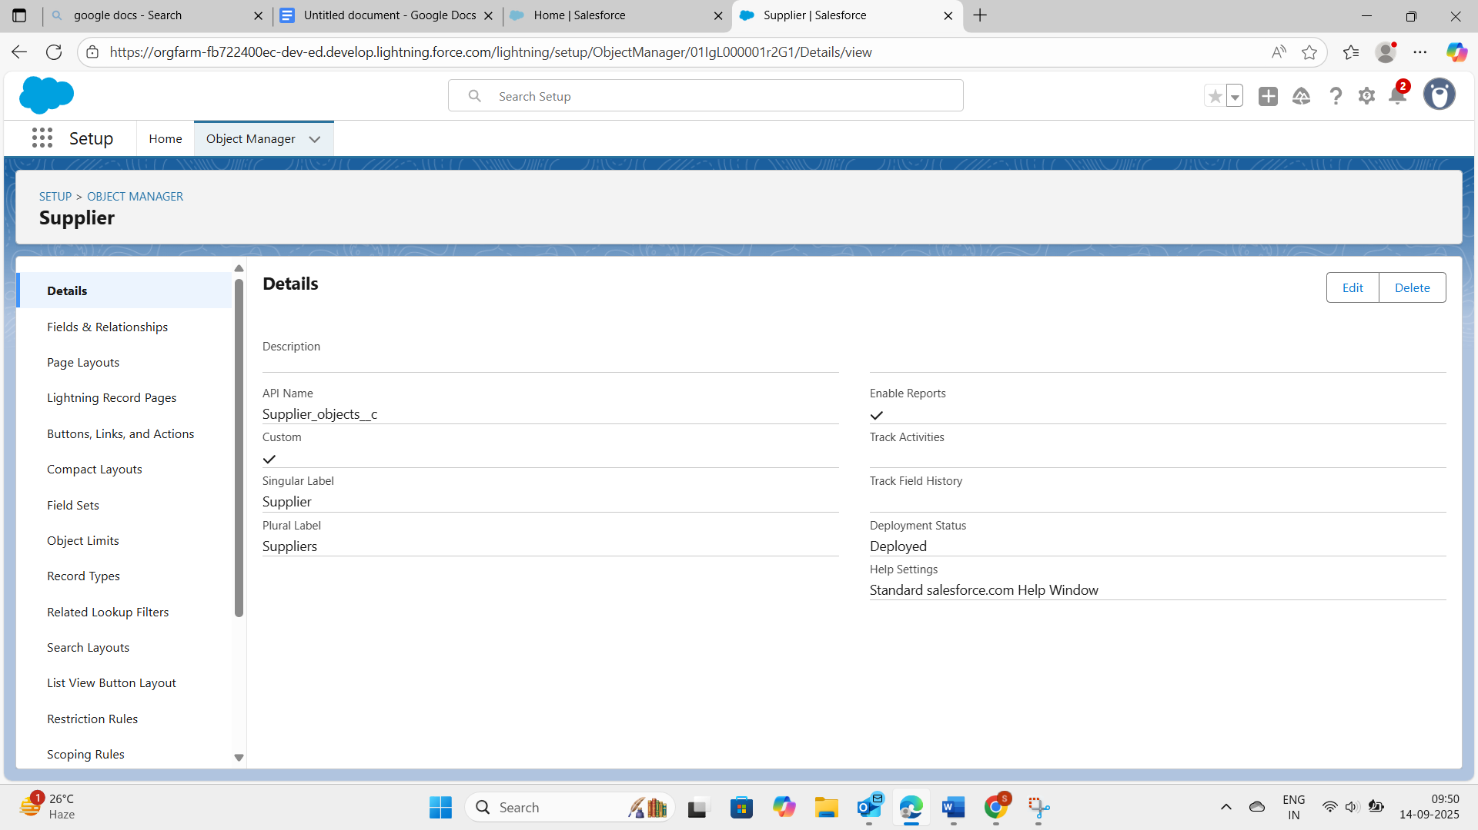

The above all the screenshots are details of created objects. The objects are product,purchase order, order item, inventory transaction, and supplier . then move to the next part fields and relationships on the objects

* **Configured fields and relationships**

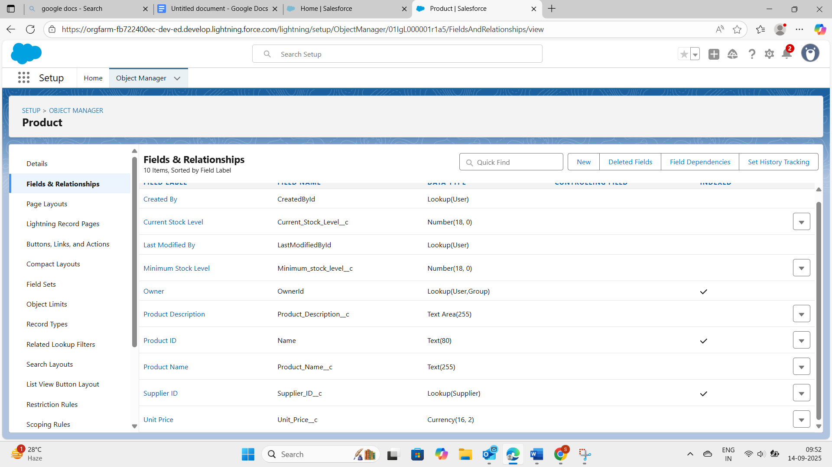

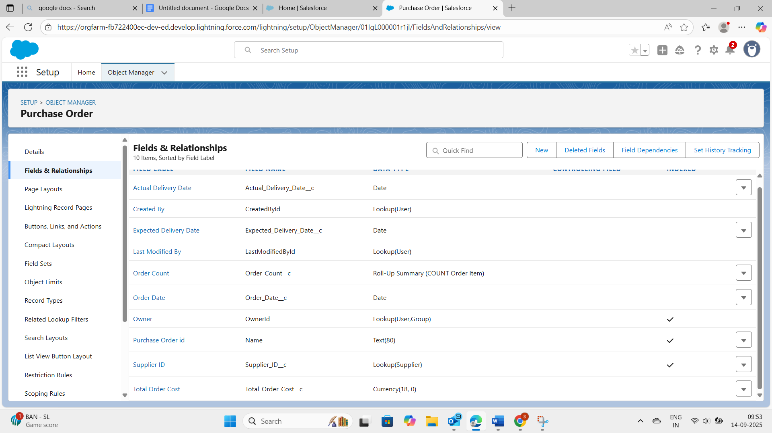

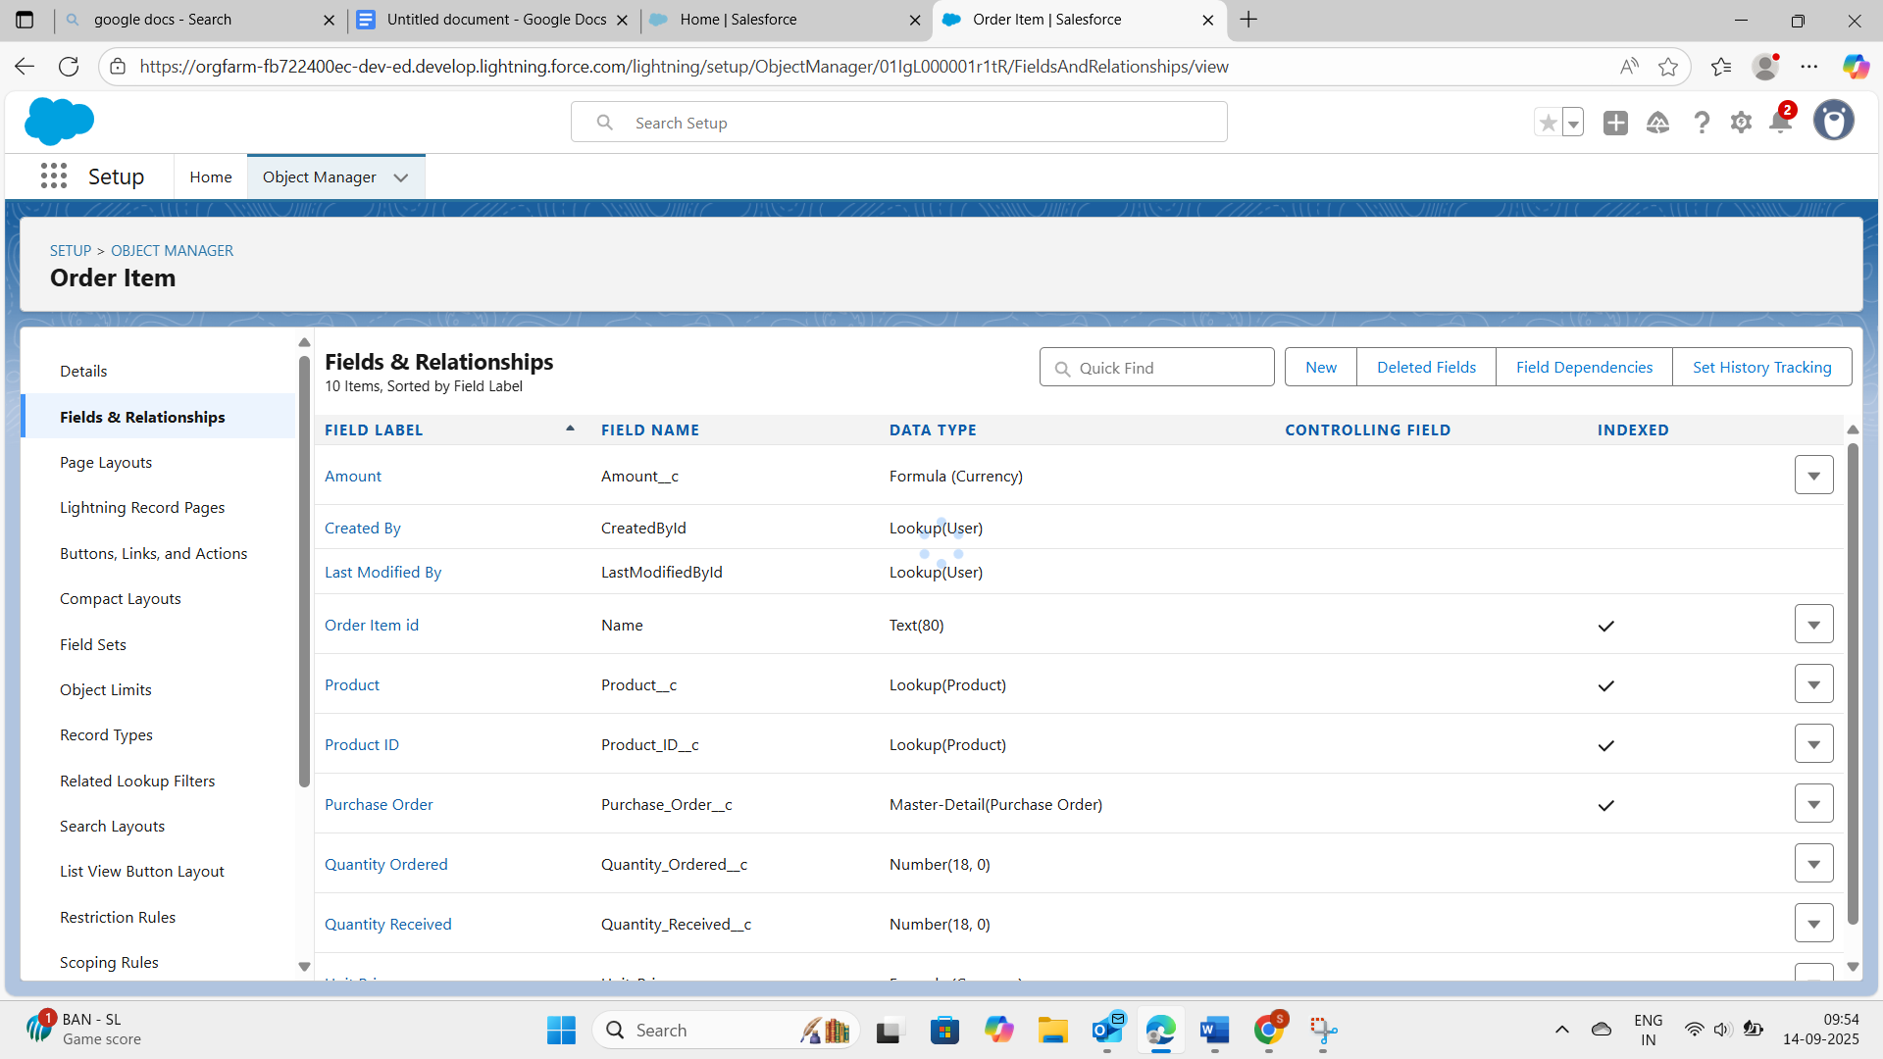

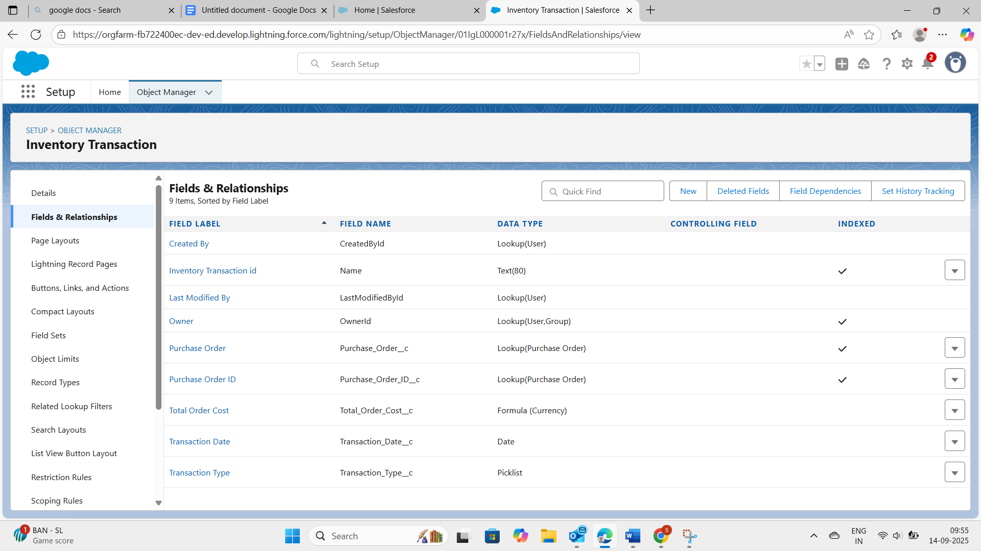

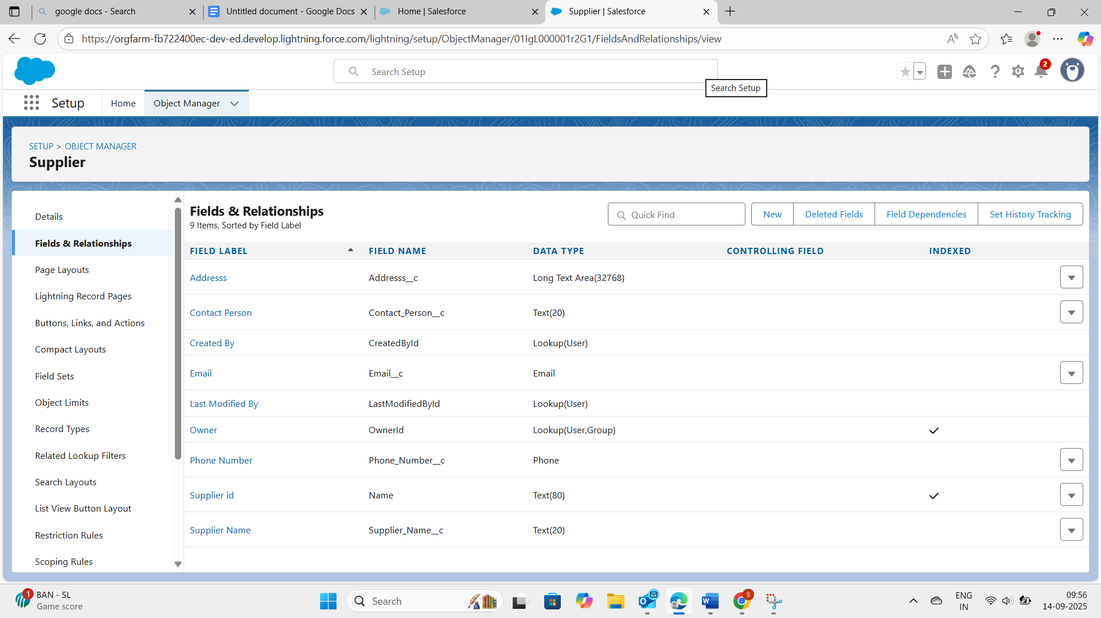

**● Developed Lightning App with relevant tabs**

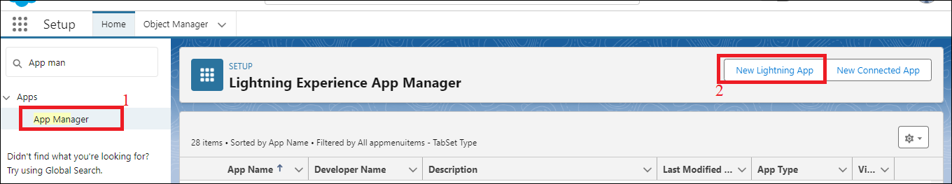

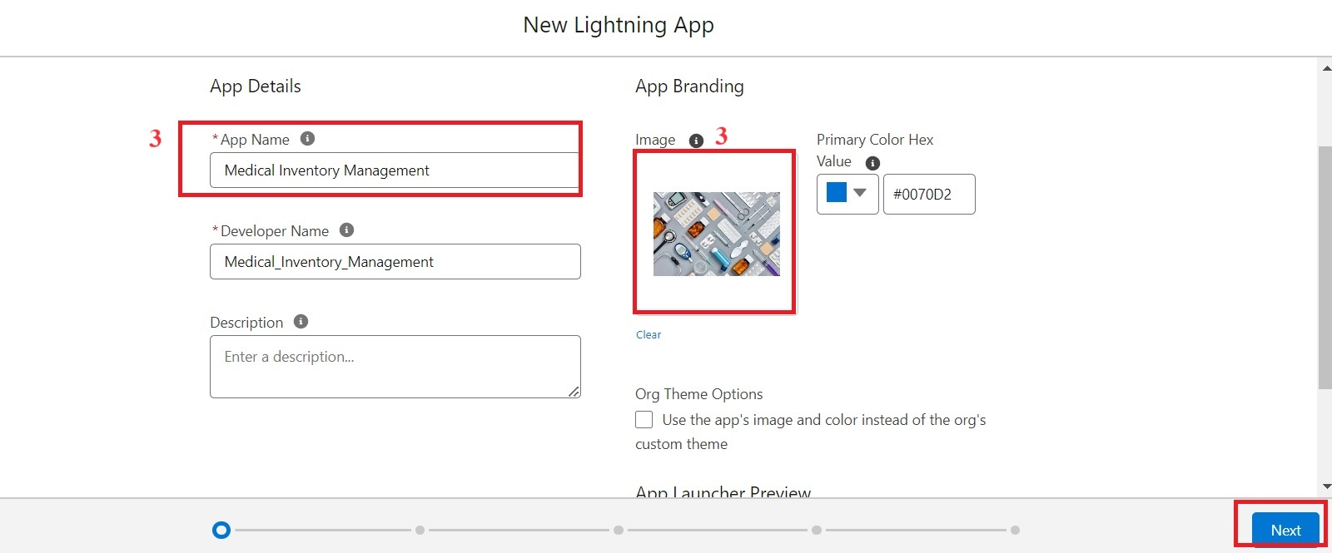

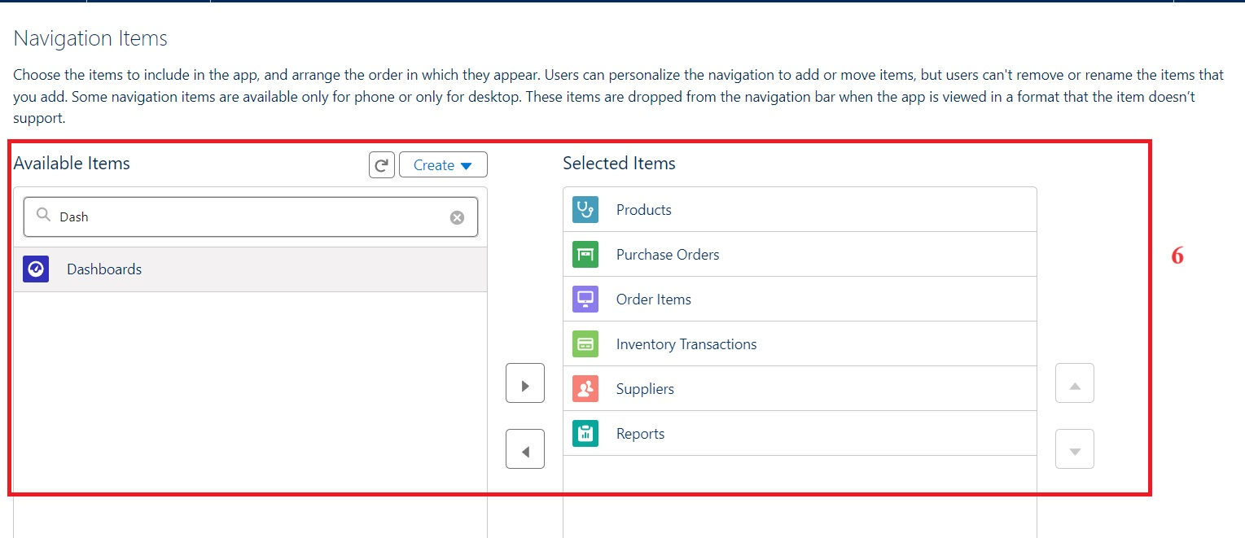

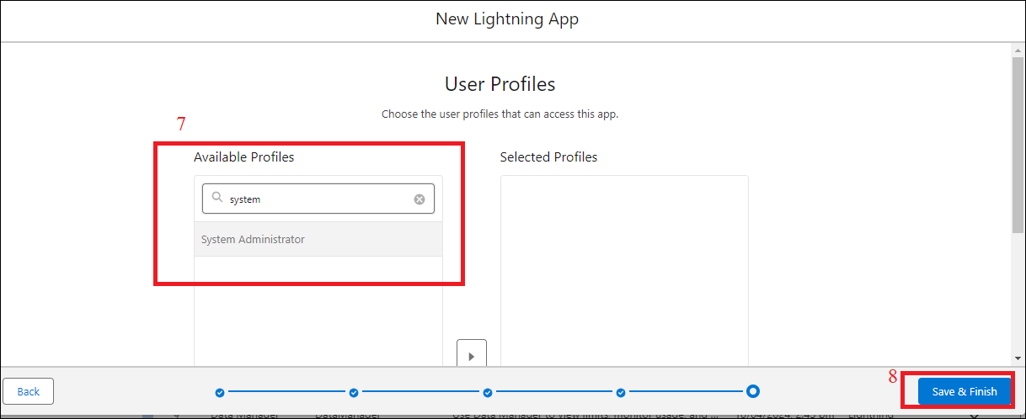

* **Editing page layouts**

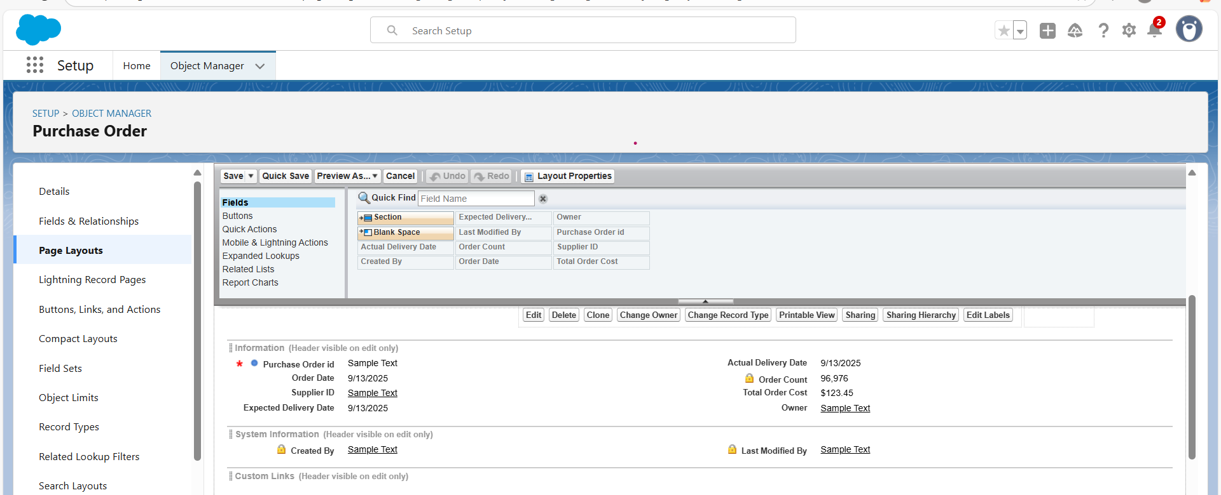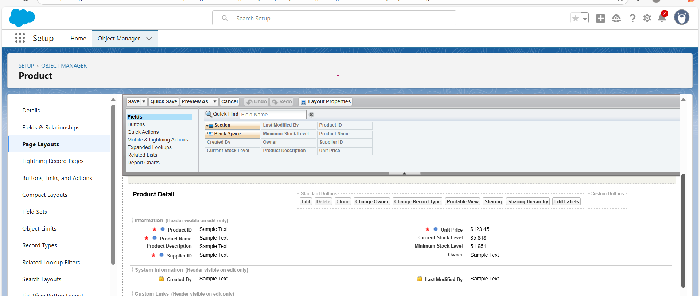

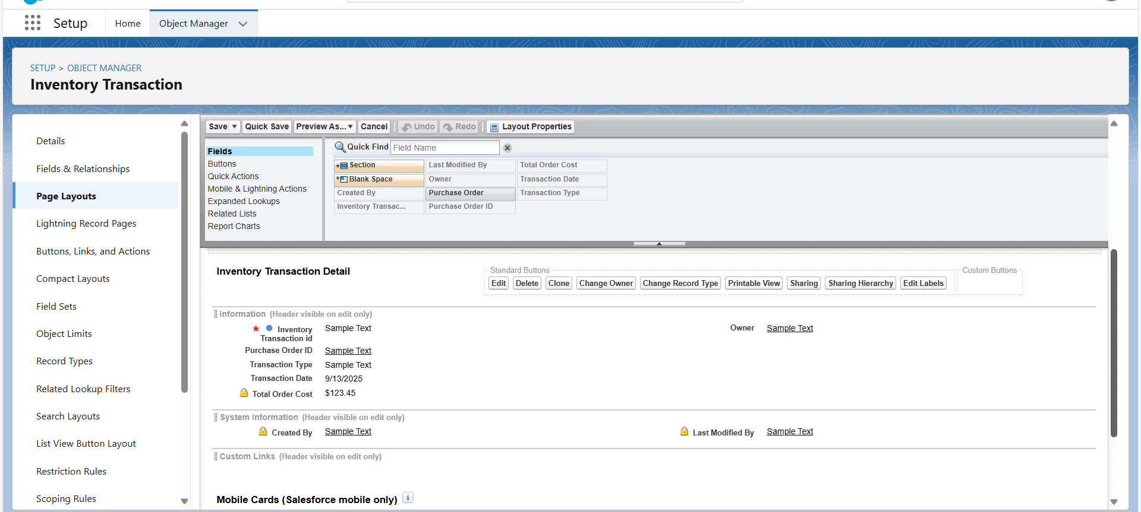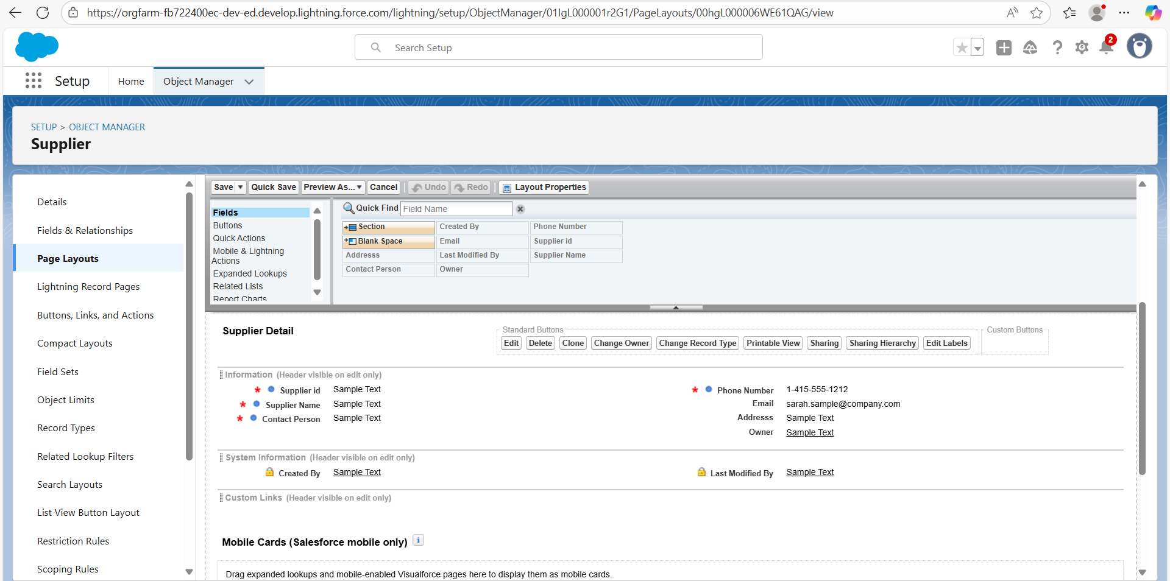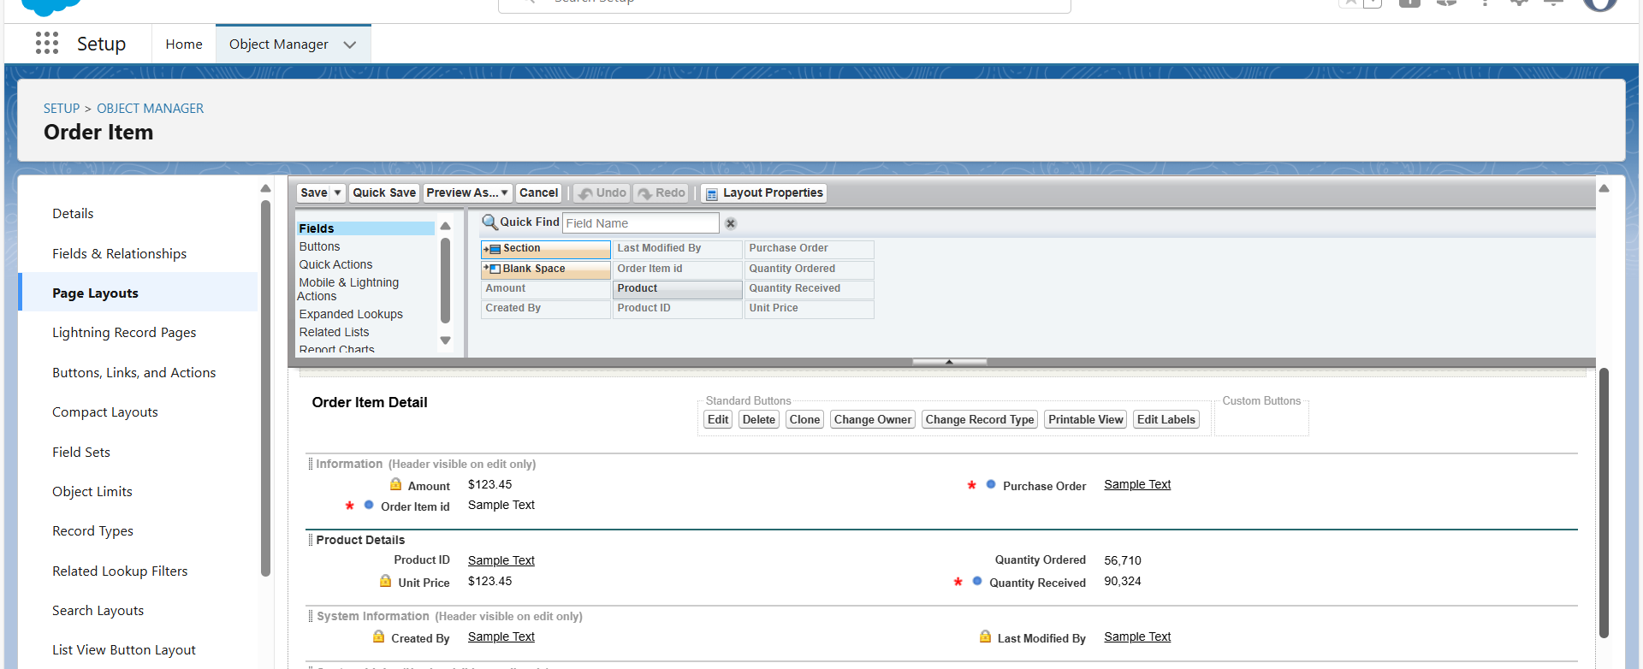

### **create a Compact Layout to a Product Object**

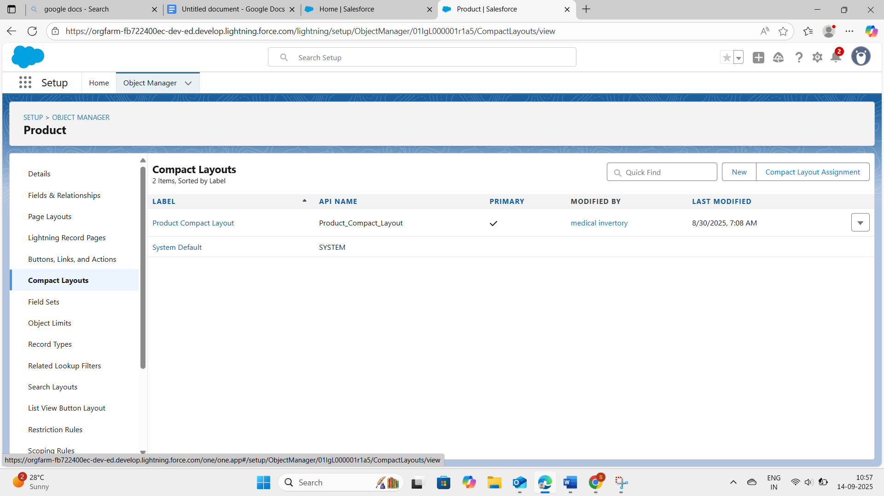

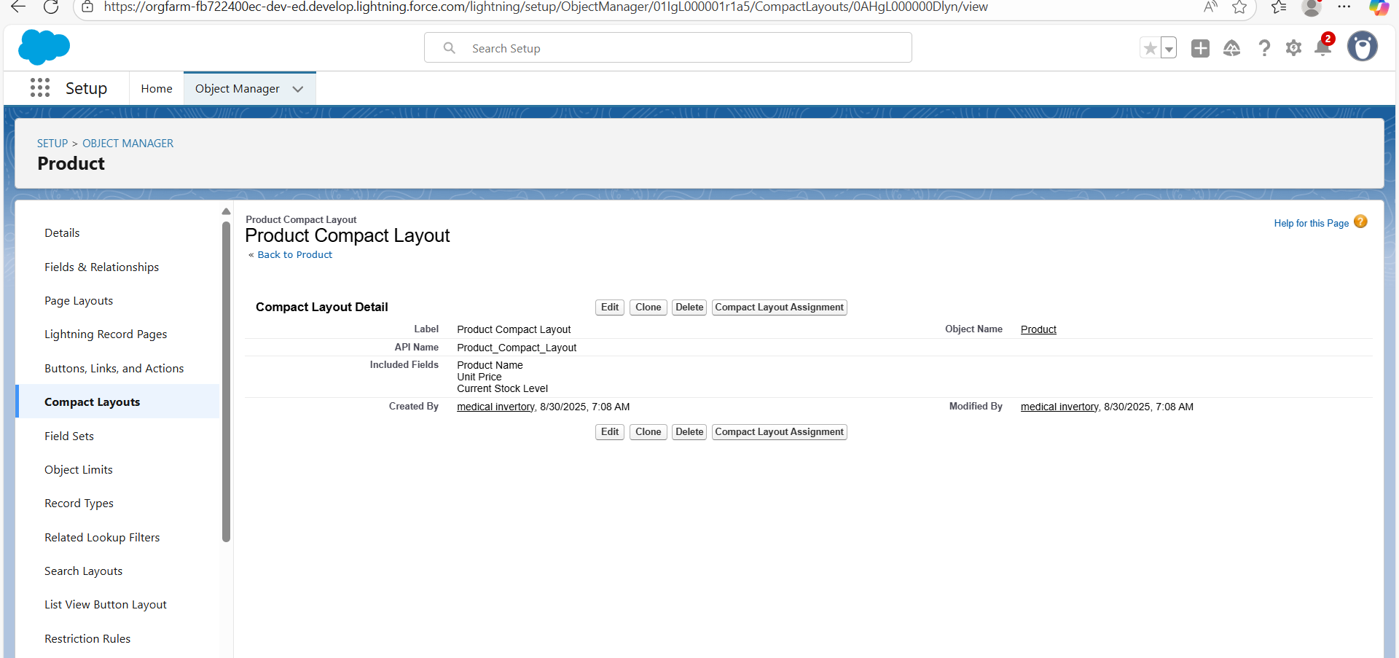

### **create a Compact Layout to a Purchase Order Object**

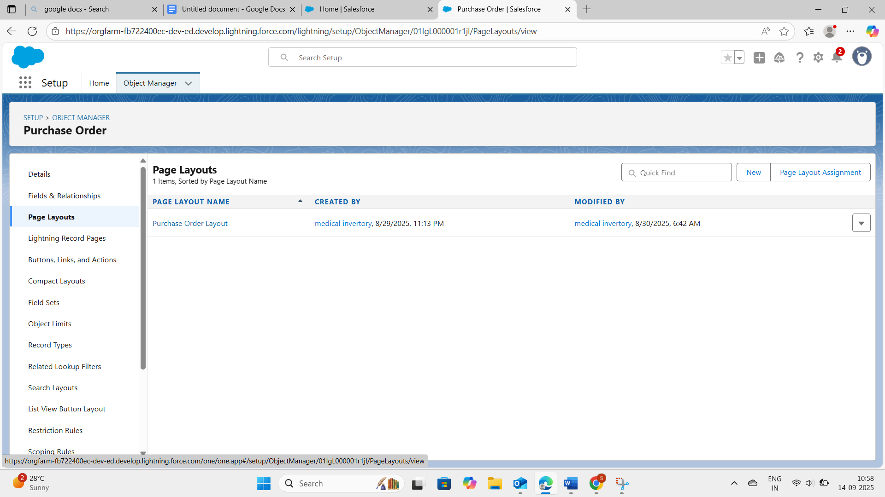

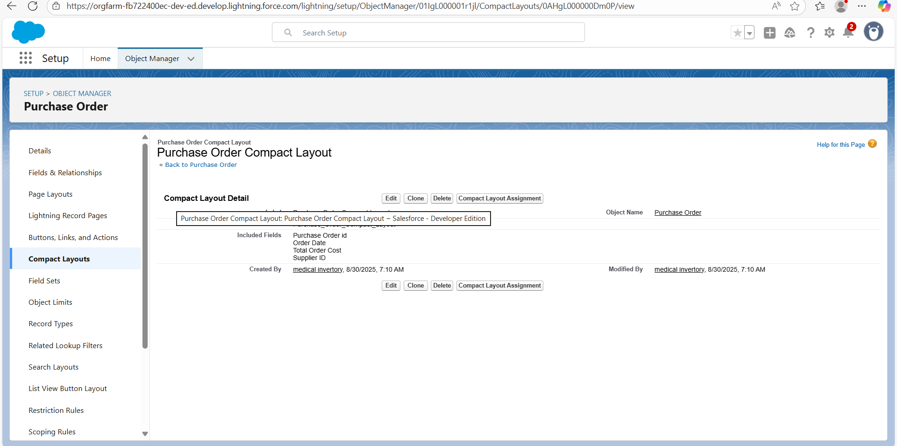

### **create an Expected Delivery Date Validation rule to a Employee Object**

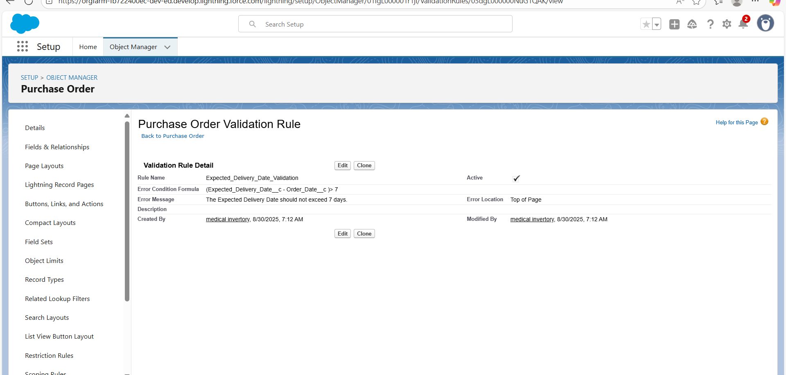

### **create an Inventory Manager Profile**

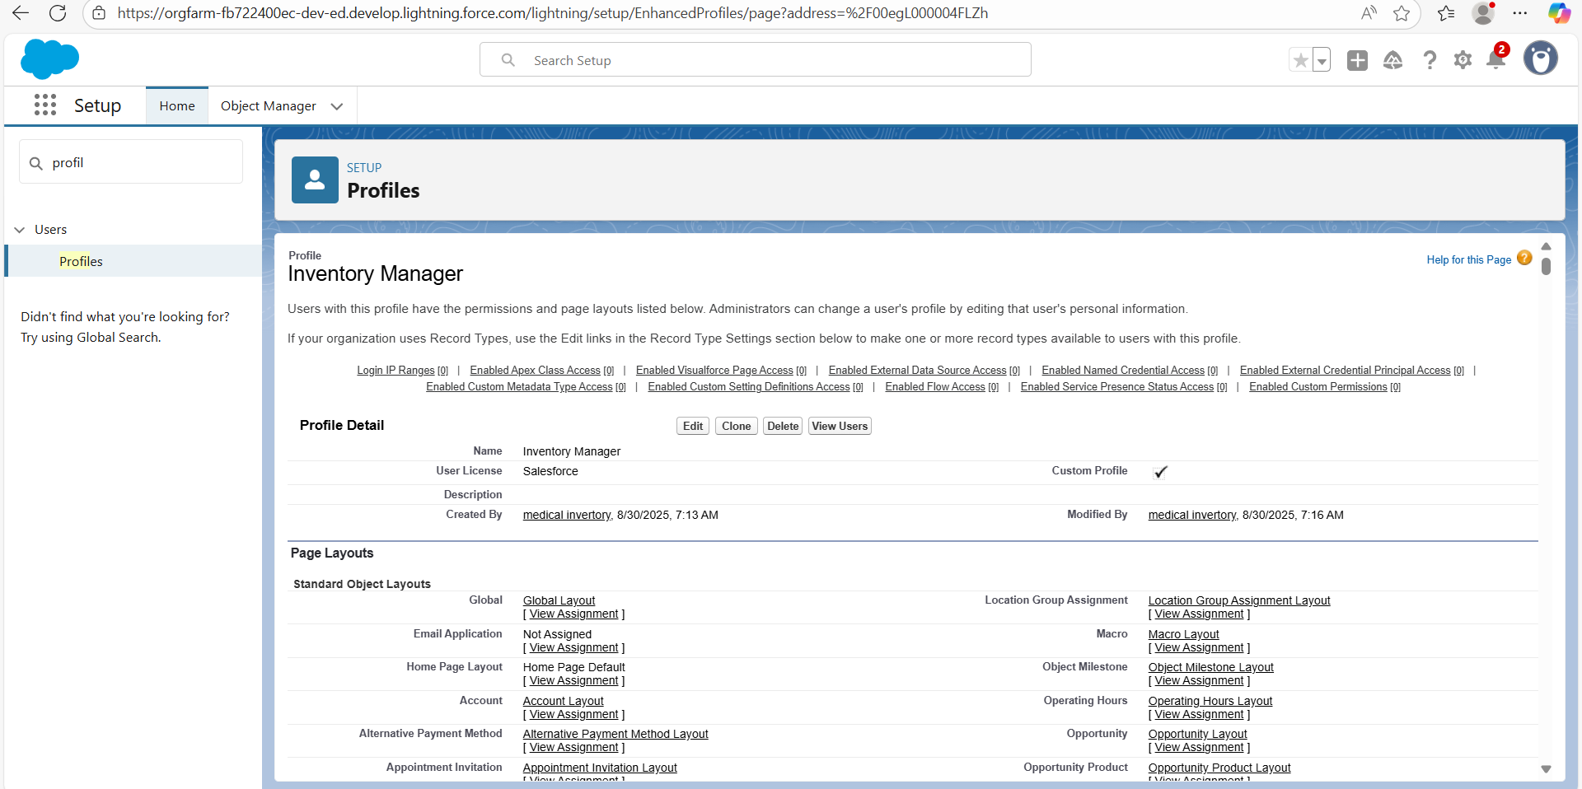

### **create an Purchase Manager Profile**

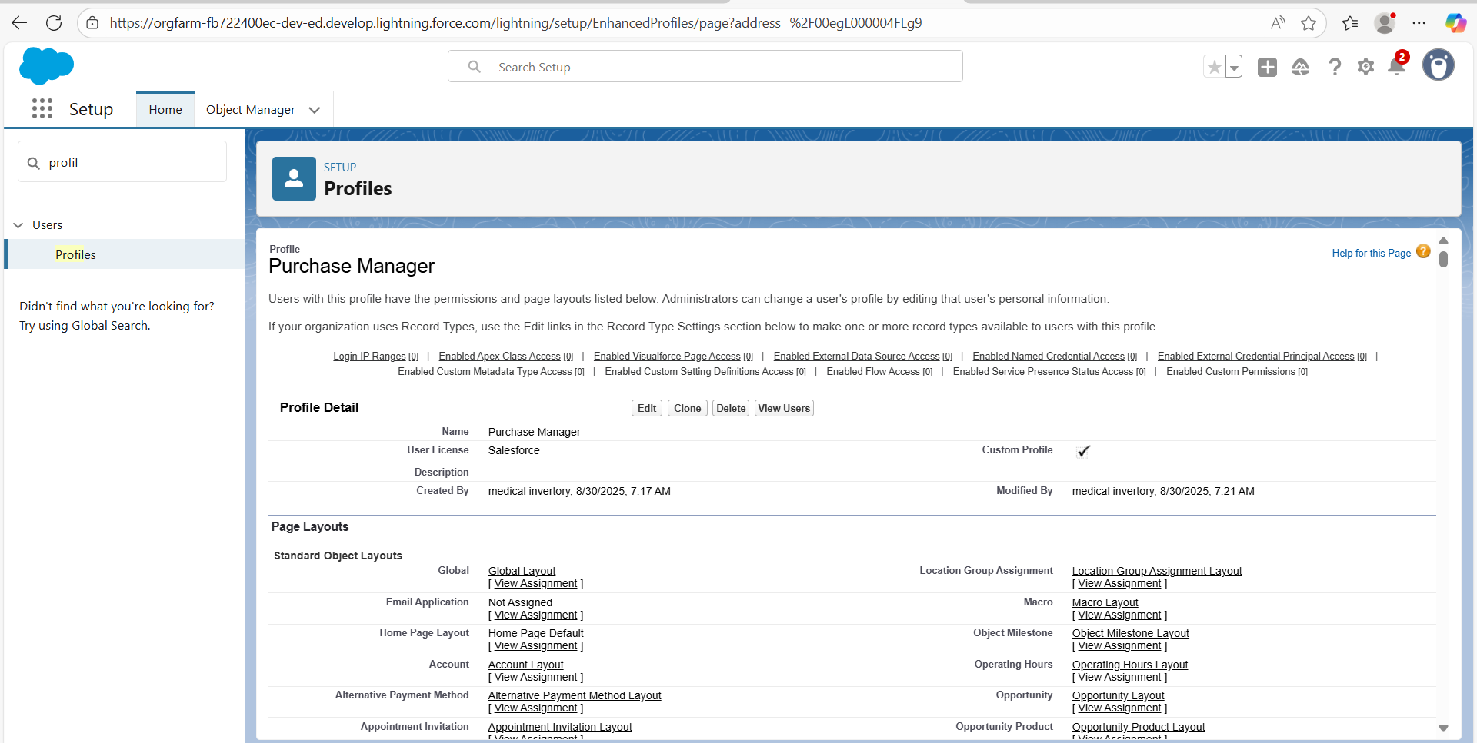

### **Create a Purchasing Manager Role**

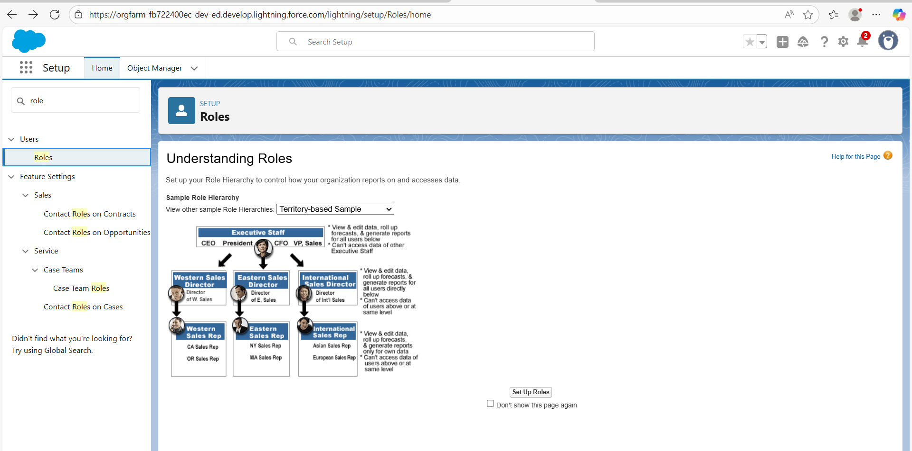

### **Create a Permission Set**

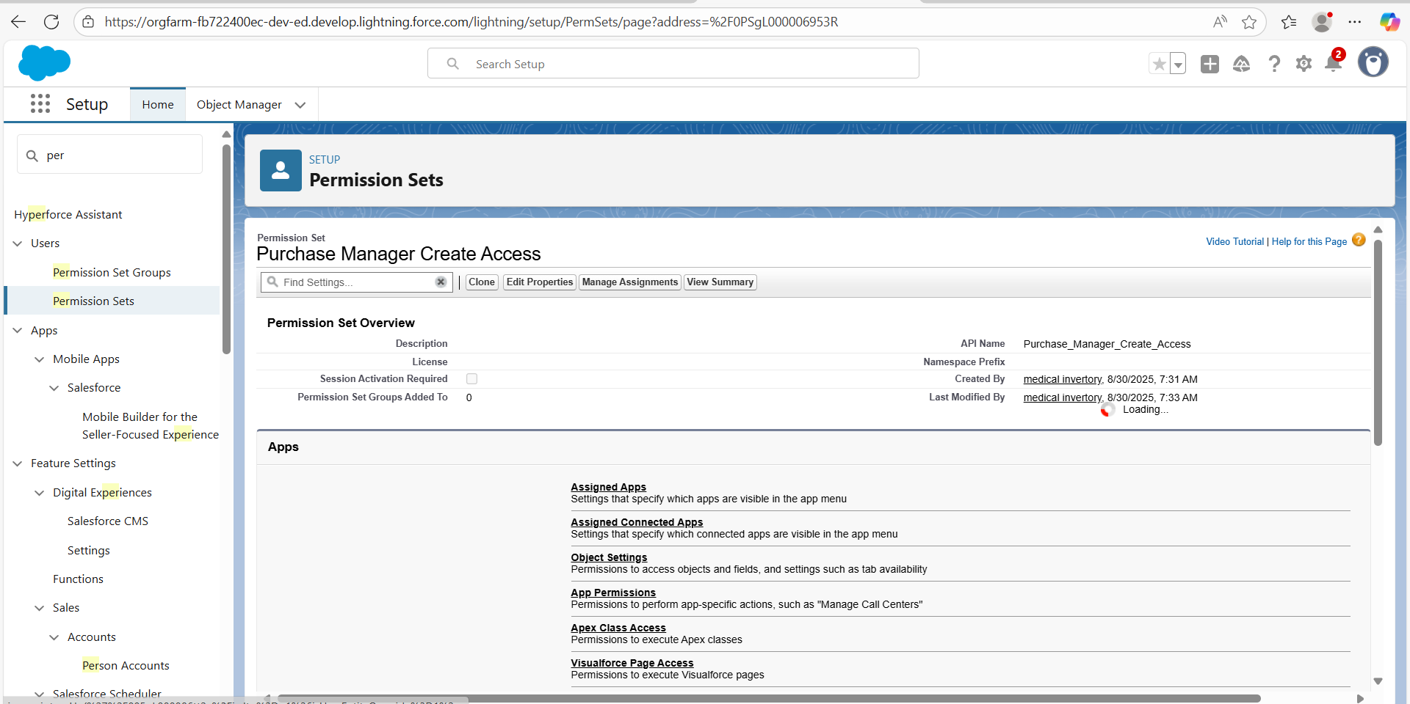

### **Create Flow to update the Actual Delivery Date**

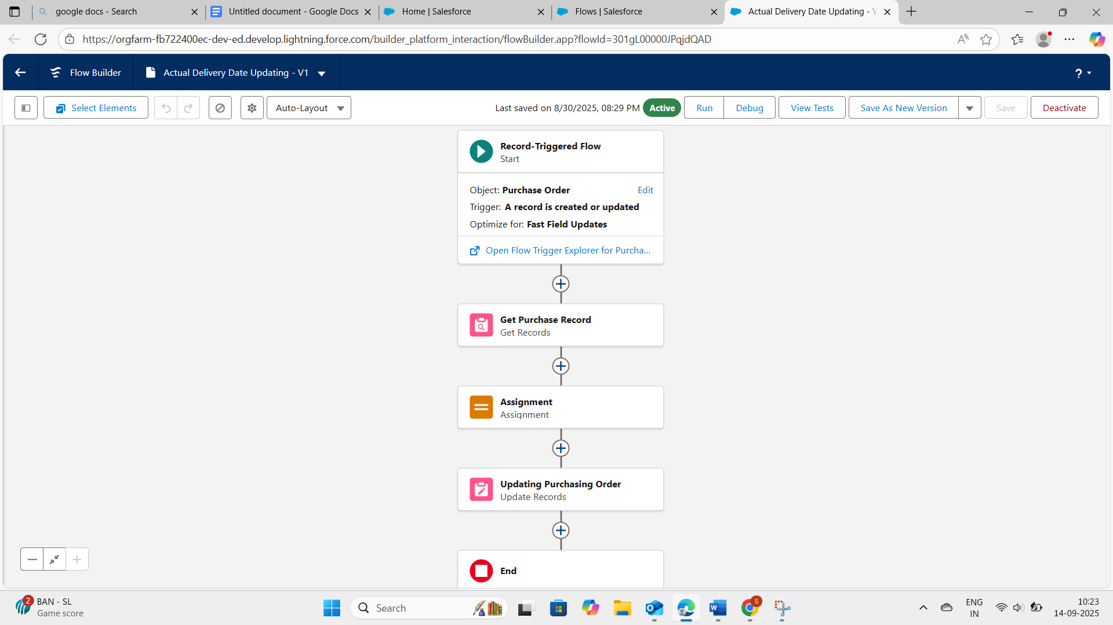

### **Create a Trigger to Calculate total amount on Order Item**

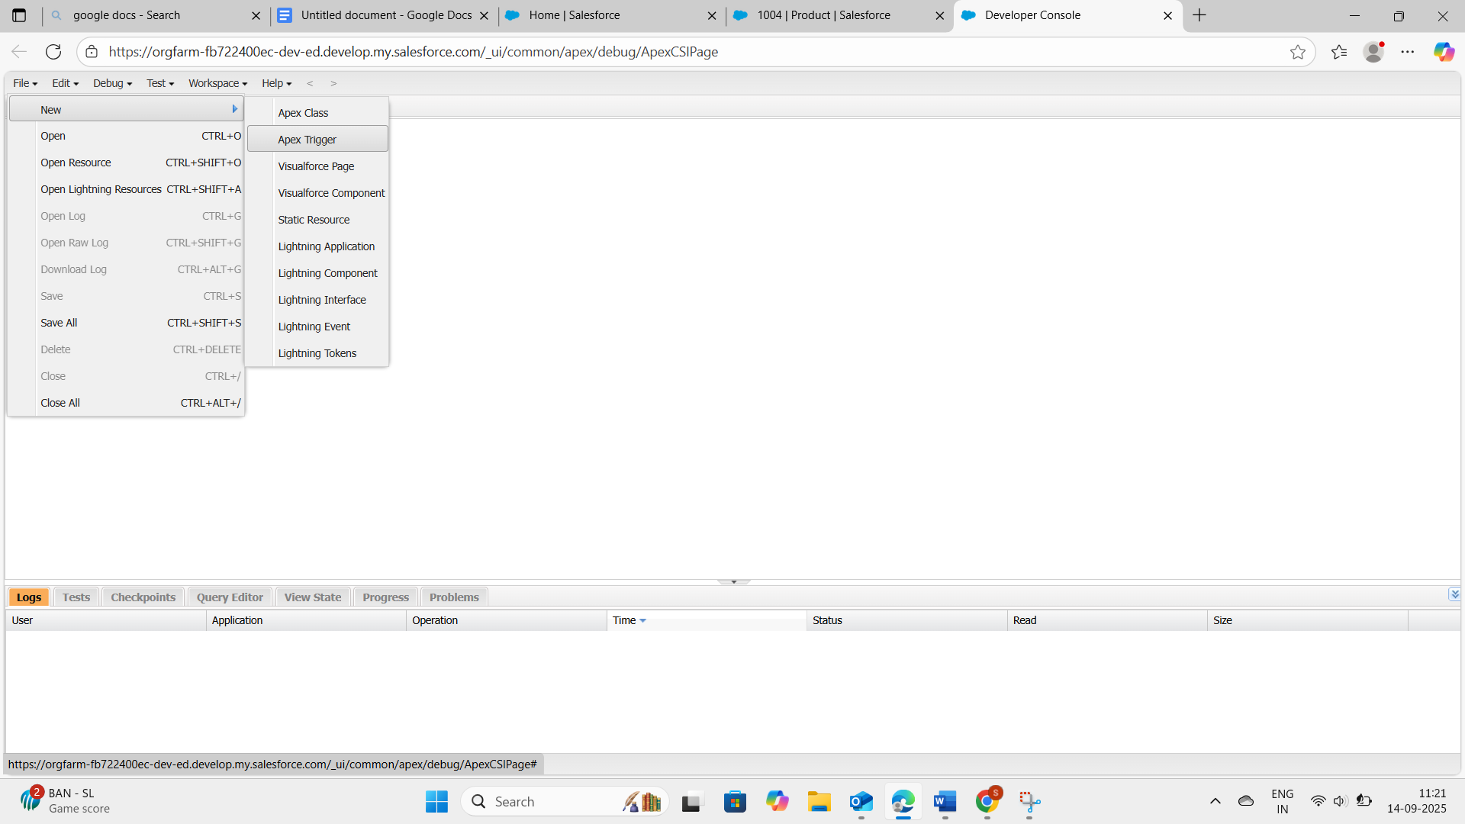

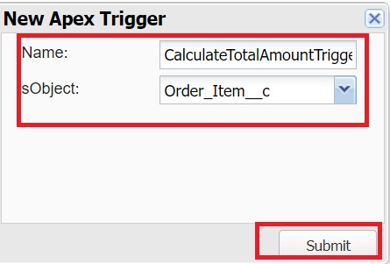

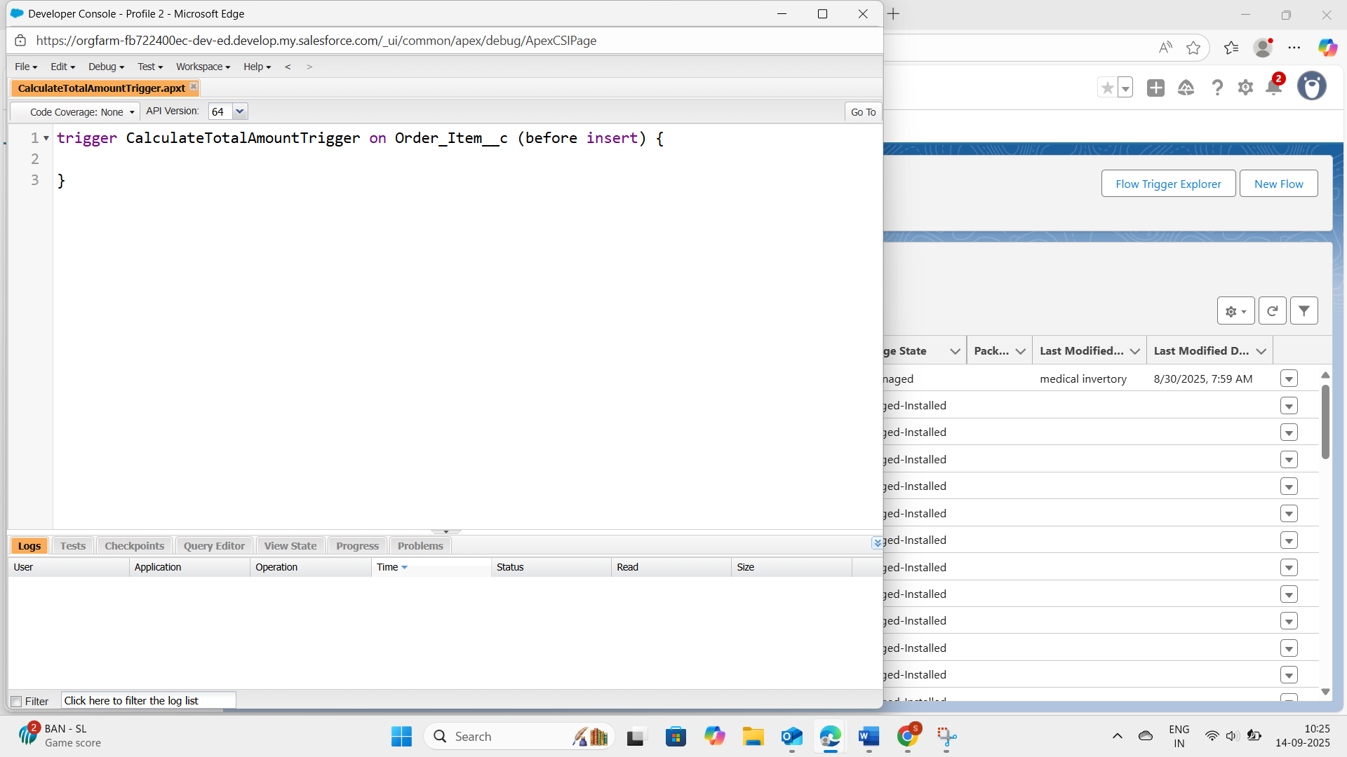

**Create an Apex Trigger:**

trigger CalculateTotalAmountTrigger on Order_Item__c (after insert, after update, after delete, after undelete) {

// Call the handler class to handle the logic

CalculateTotalAmountHandler.calculateTotal(Trigger.new, Trigger.old, Trigger.isInsert, Trigger.isUpdate, Trigger.isDelete, Trigger.isUndelete);

}

i) In the Developer Console window, go to the top menu and click on "File".

ii)Select New: From the dropdown menu under "File", select "New".

iii)Choose Apex Class: Name it as CalculateTotalAmountHandler

public class CalculateTotalAmountHandler {

// Method to calculate the total amount for Purchase Orders based on related Order Items

public static void calculateTotal(List<Order_Item__c> newItems, List<Order_Item__c> oldItems, Boolean isInsert, Boolean isUpdate, Boolean isDelete, Boolean isUndelete) {

// Collect Purchase Order IDs affected by changes

Order_Item__c records

Set<Id> parentIds = new Set<Id>();

// For insert, update, and undelete scenarios

if (isInsert || isUpdate || isUndelete) {

for (Order_Item__c ordItem : newItems) {

parentIds.add(ordItem.Purchase_Order_Id__c);

}

}

// For update and delete scenarios

if (isUpdate || isDelete) {

for (Order_Item__c ordItem : oldItems) {

parentIds.add(ordItem.Purchase_Order_Id__c);

}

}

// Calculate the total amounts for affected Purchase Orders

Map<Id, Decimal> purchaseToUpdateMap = new Map<Id, Decimal>();

if (!parentIds.isEmpty()) {

// Perform an aggregate query to sum the Amount__c for each Purchase Order

List<AggregateResult> aggrList = [

SELECT Purchase_Order_Id__c, SUM(Amount__c) totalAmount

FROM Order_Item__c

WHERE Purchase_Order_Id__c IN :parentIds

GROUP BY Purchase_Order_Id__c

];

// Map the result to Purchase Order IDs

for (AggregateResult aggr : aggrList) {

Id purchaseOrderId = (Id)aggr.get('Purchase_Order_Id__c');

Decimal totalAmount = (Decimal)aggr.get('totalAmount');

purchaseToUpdateMap.put(purchaseOrderId, totalAmount);

}

// Prepare Purchase Order records for update

List<Purchase_Order__c> purchaseToUpdate = new List<Purchase_Order__c>();

for (Id purchaseOrderId : purchaseToUpdateMap.keySet()) {

Purchase_Order__c purchaseOrder = new

Purchase_Order__c(Id = purchaseOrderId, Total_Order_cost__c = purchaseToUpdateMap.get(purchaseOrderId));

purchaseToUpdate.add(purchaseOrder);

}

// Update Purchase Orders if there are any changes

if (!purchaseToUpdate.isEmpty()) {

update purchaseToUpdate;

}

}}

### **Enter a data to the fields**

* Purchase order

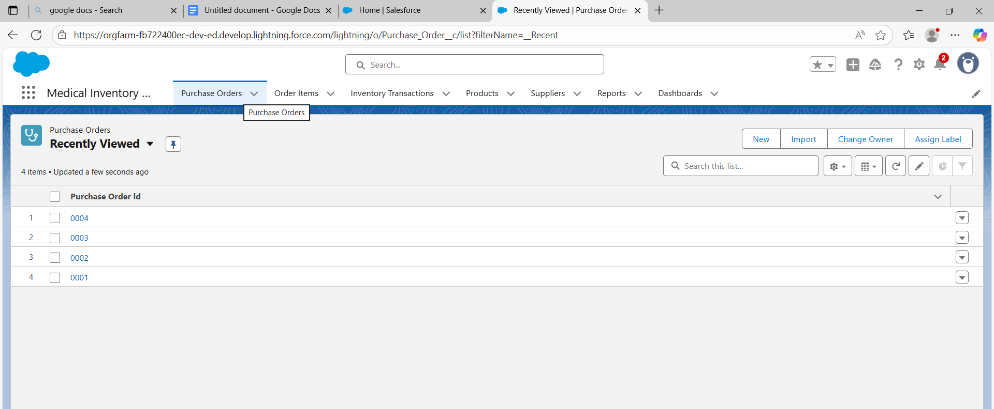

* Order item

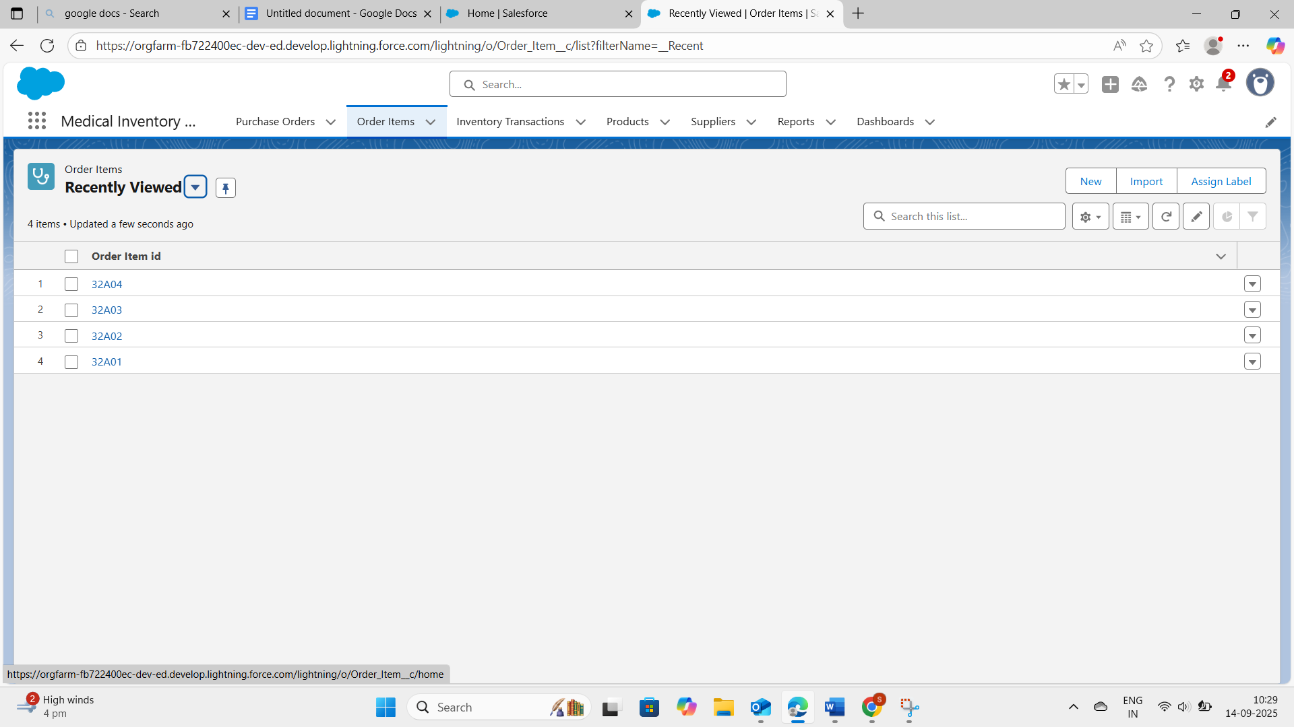

* Products

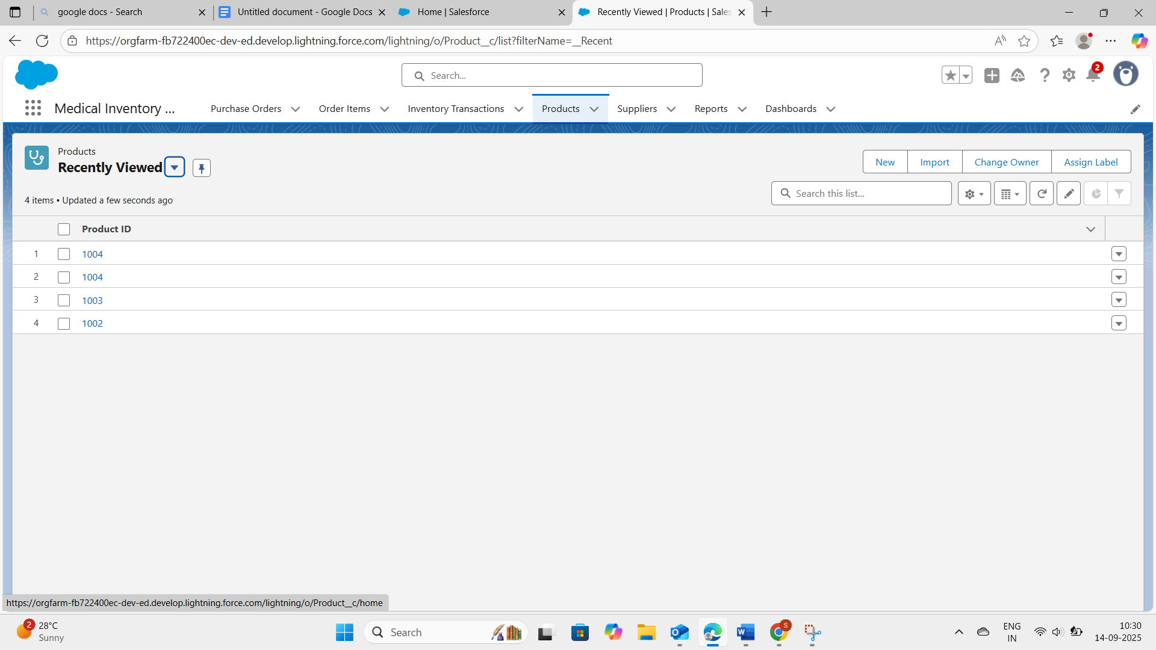

* Suppliers

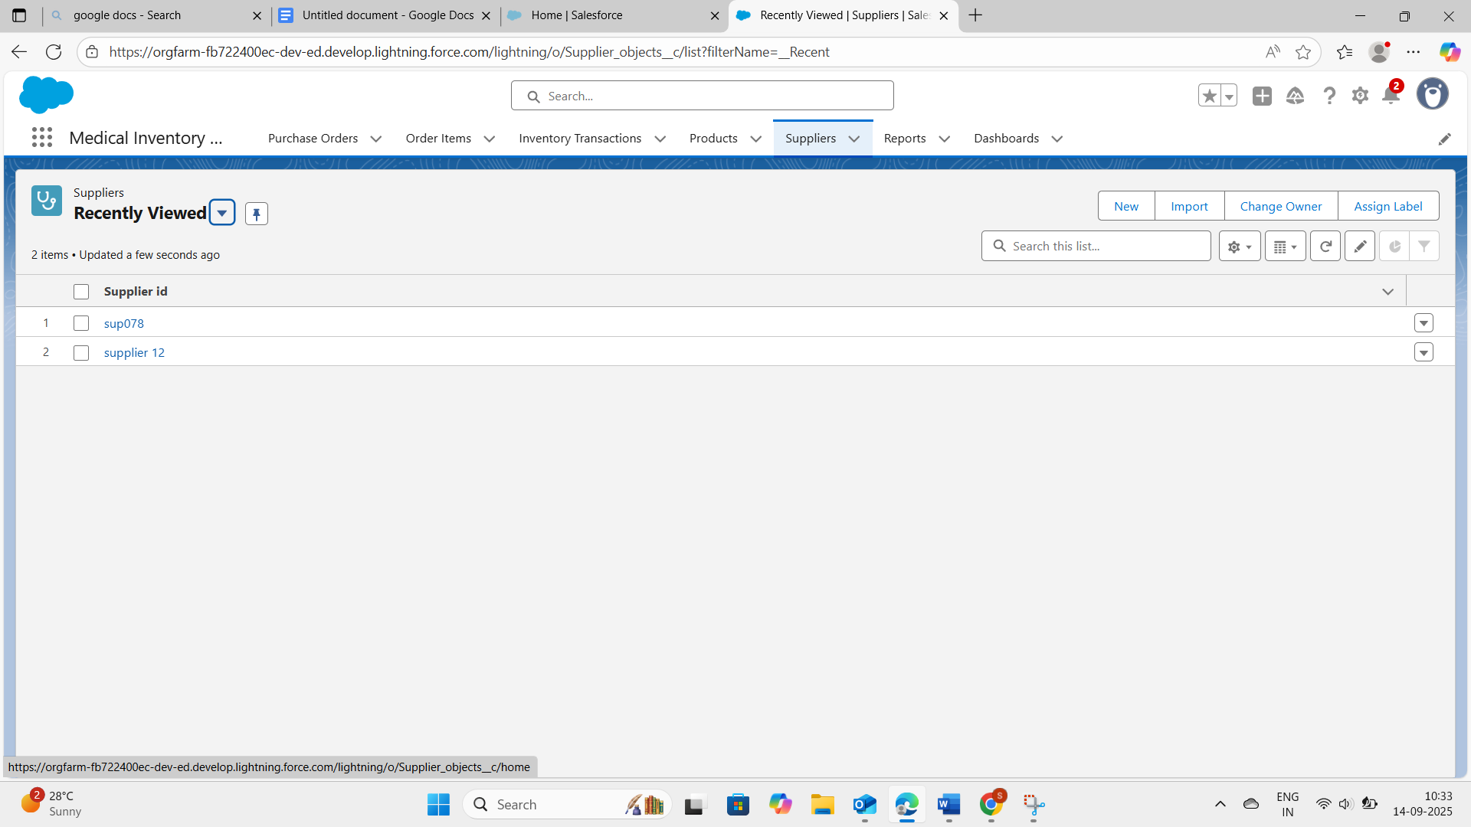

### **Create a Purchase Orders based on Suppliers(Summary) Report**

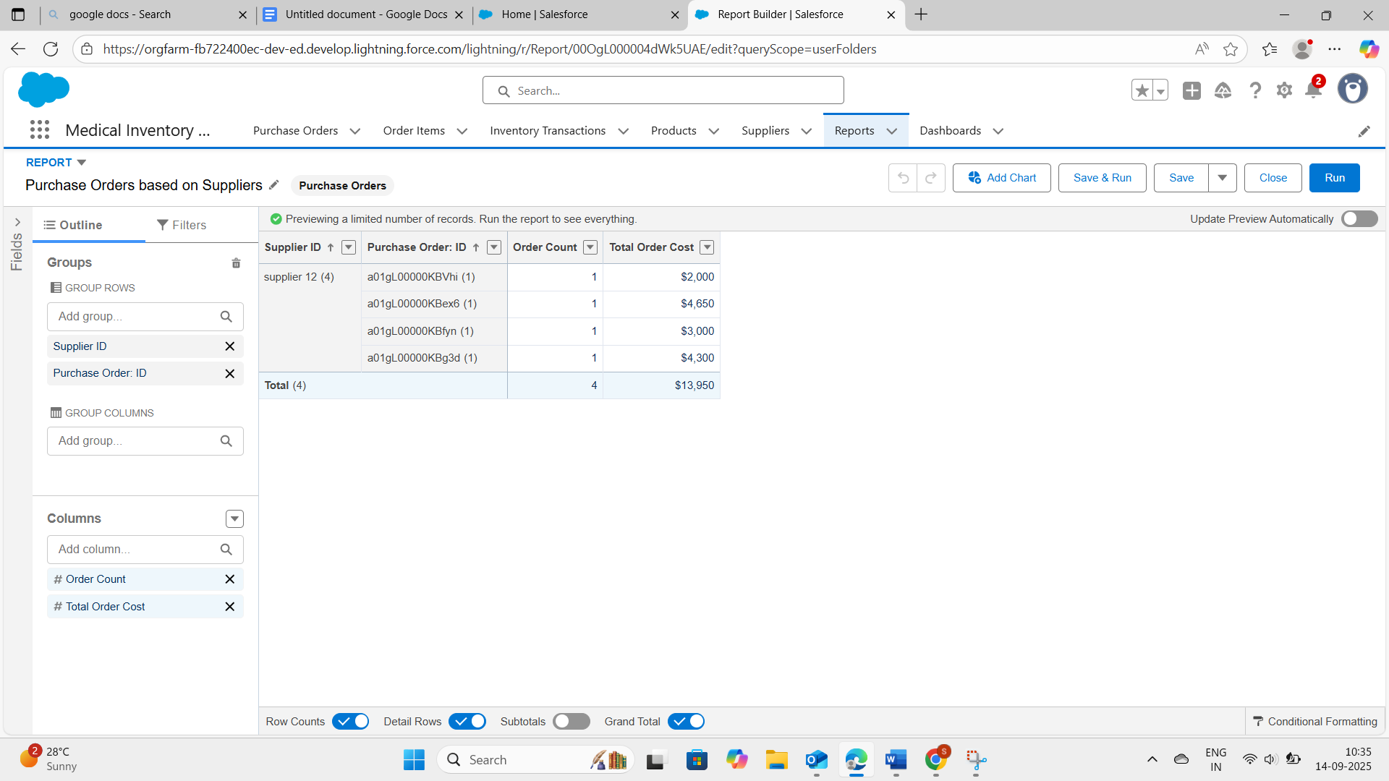

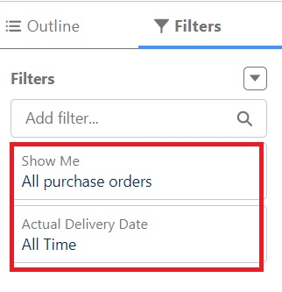

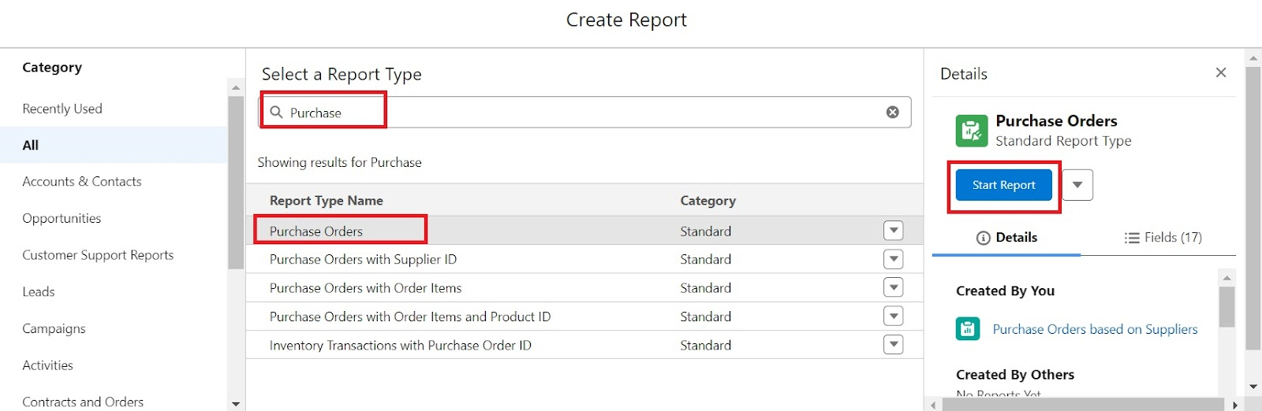

### **Create a Complete Purchase Details Report**

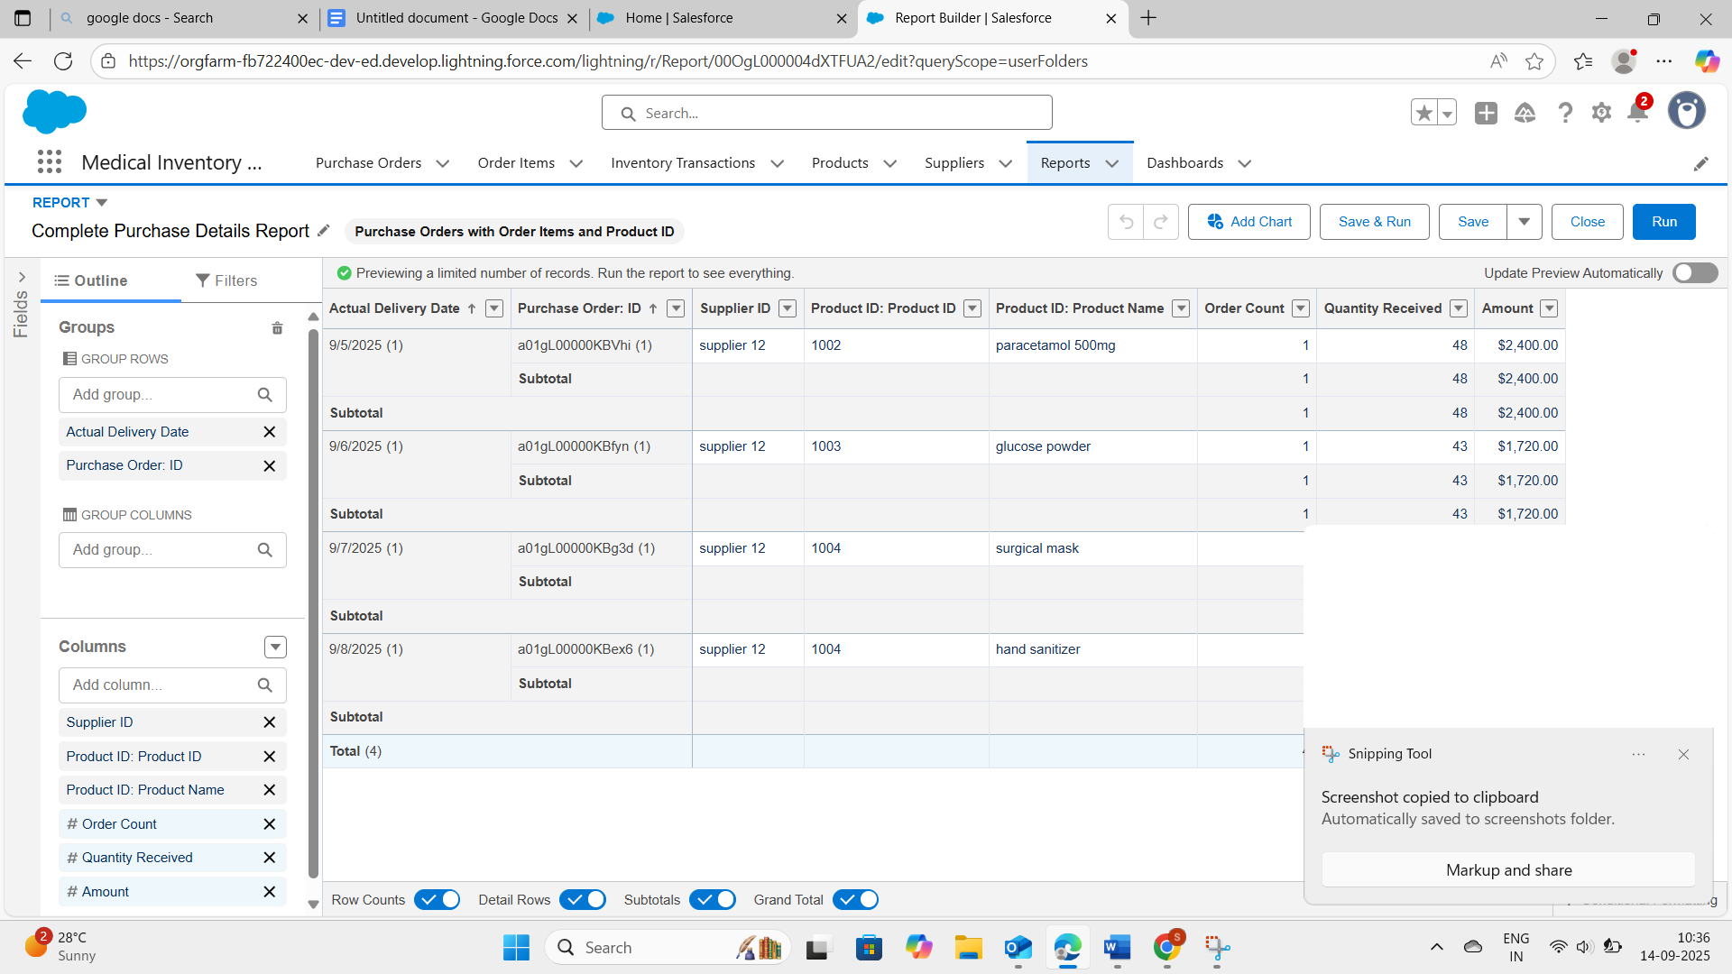

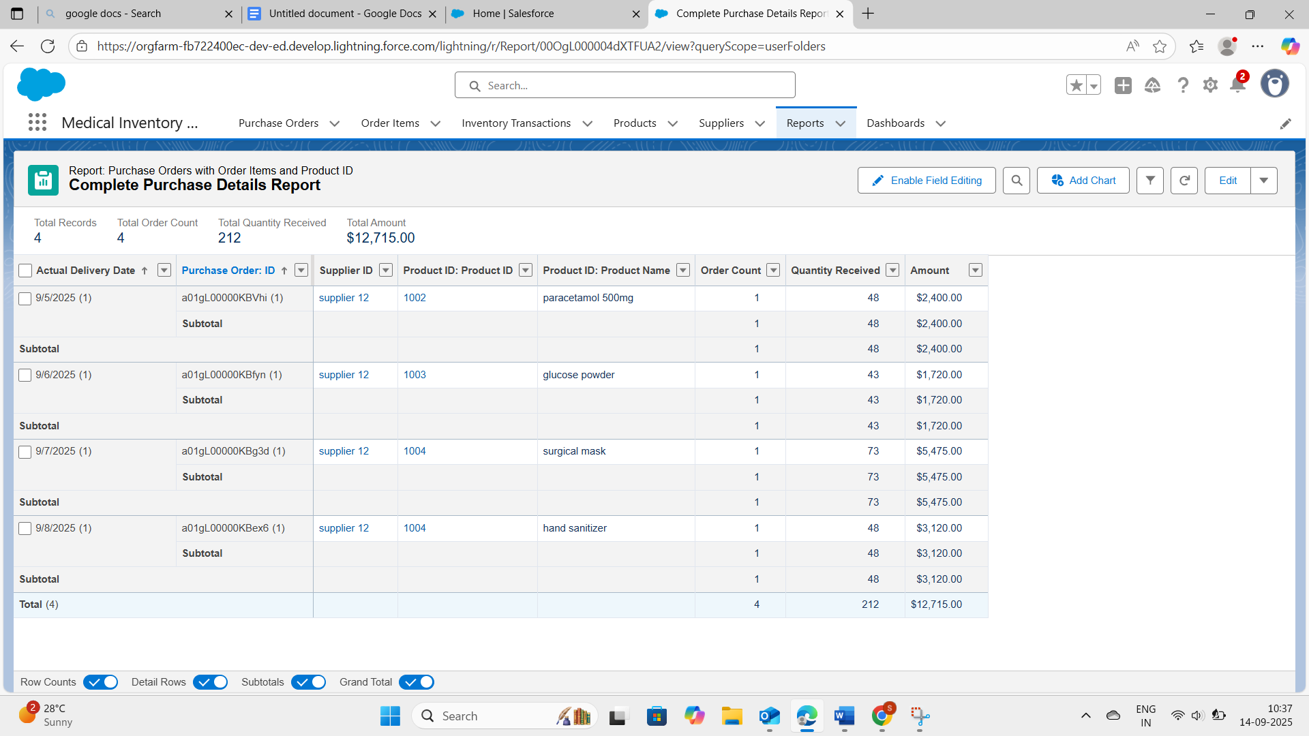

### **Create Dashboard**

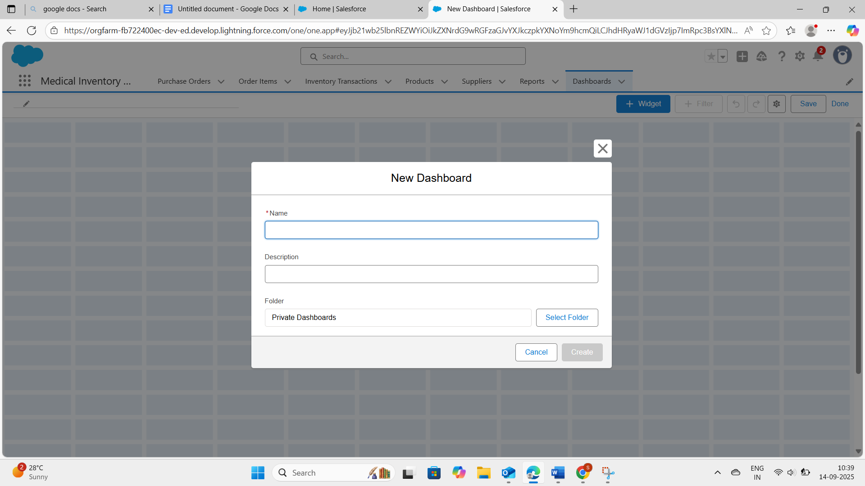

### **View Dashboard**

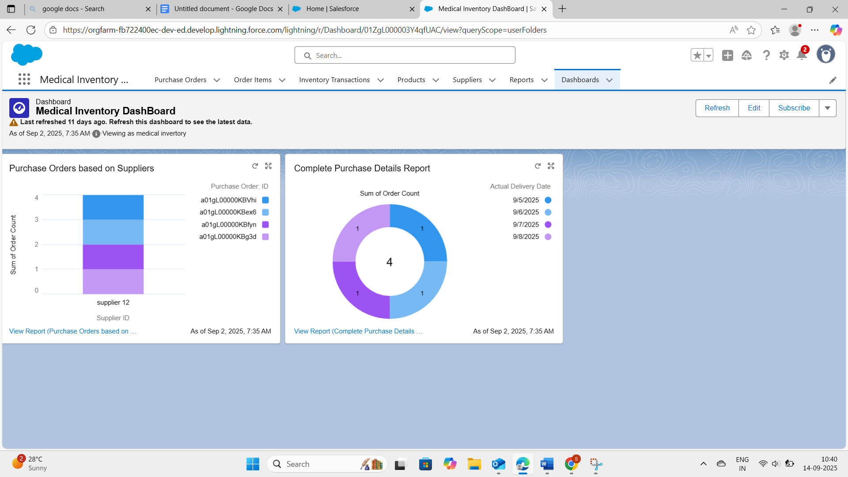

# **FUNCTIONAL AND PERFORMANCE TESTING**

## **Performance Testing**

**1.Purchase order**

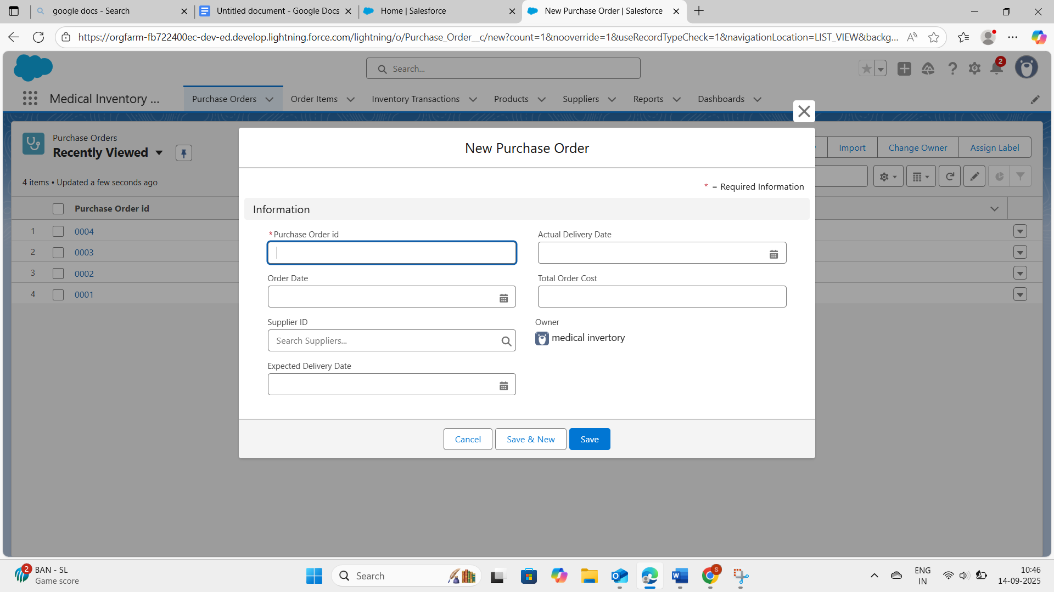

**2.Order item**

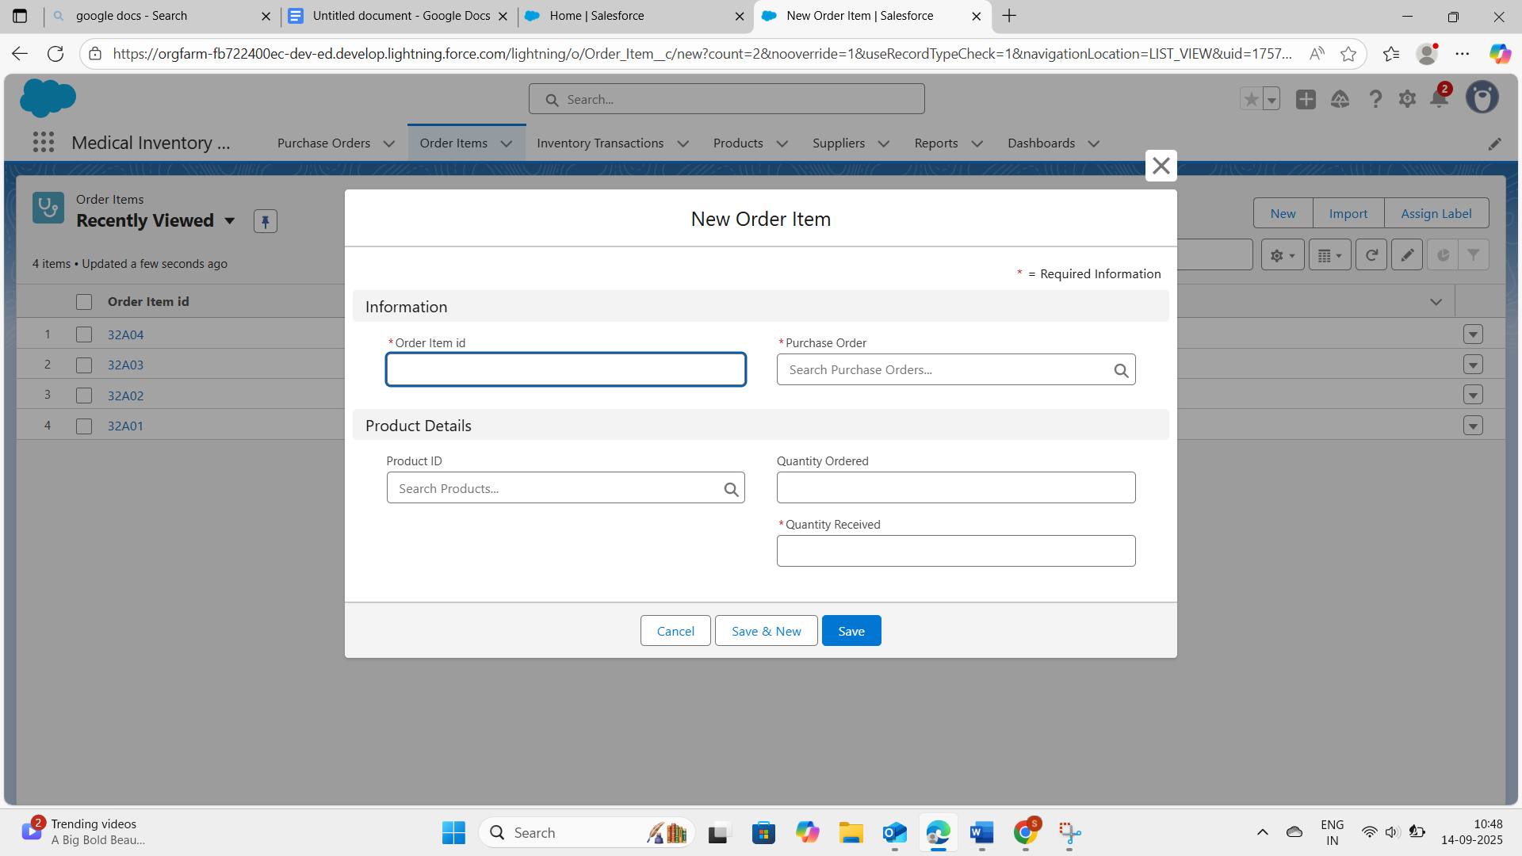

**3.Inventory Transaction**

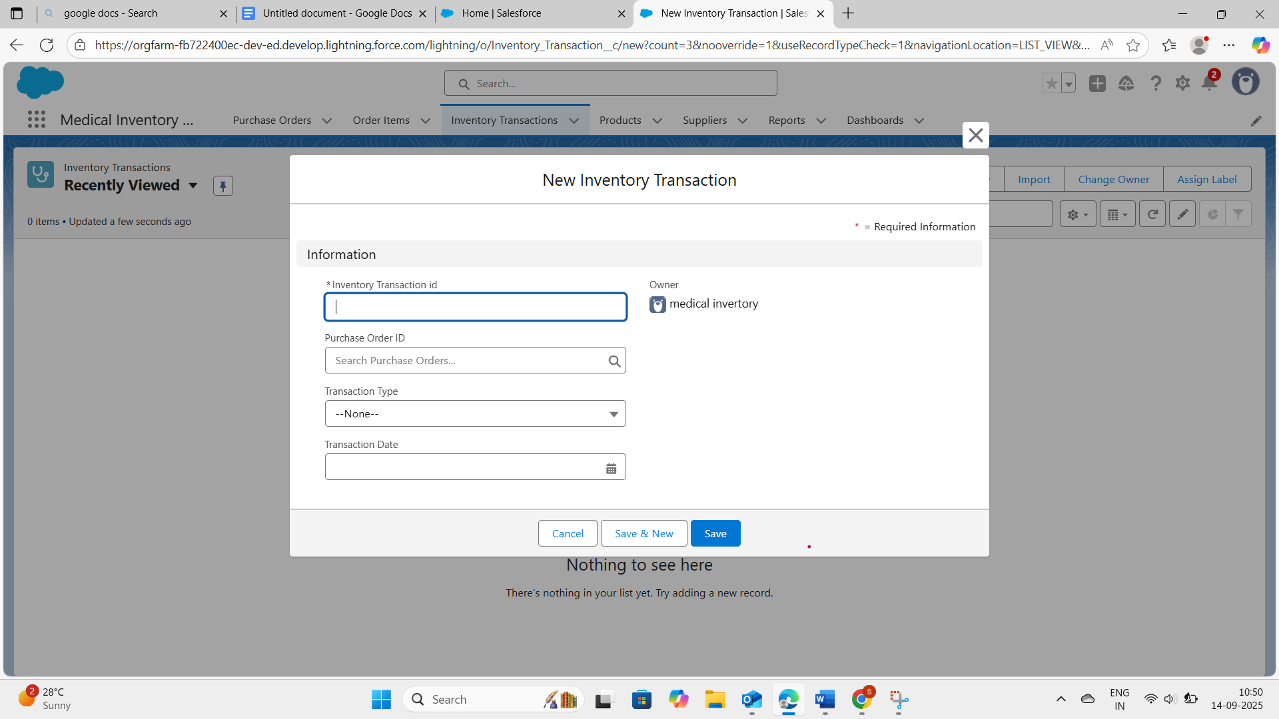

**4. Products**

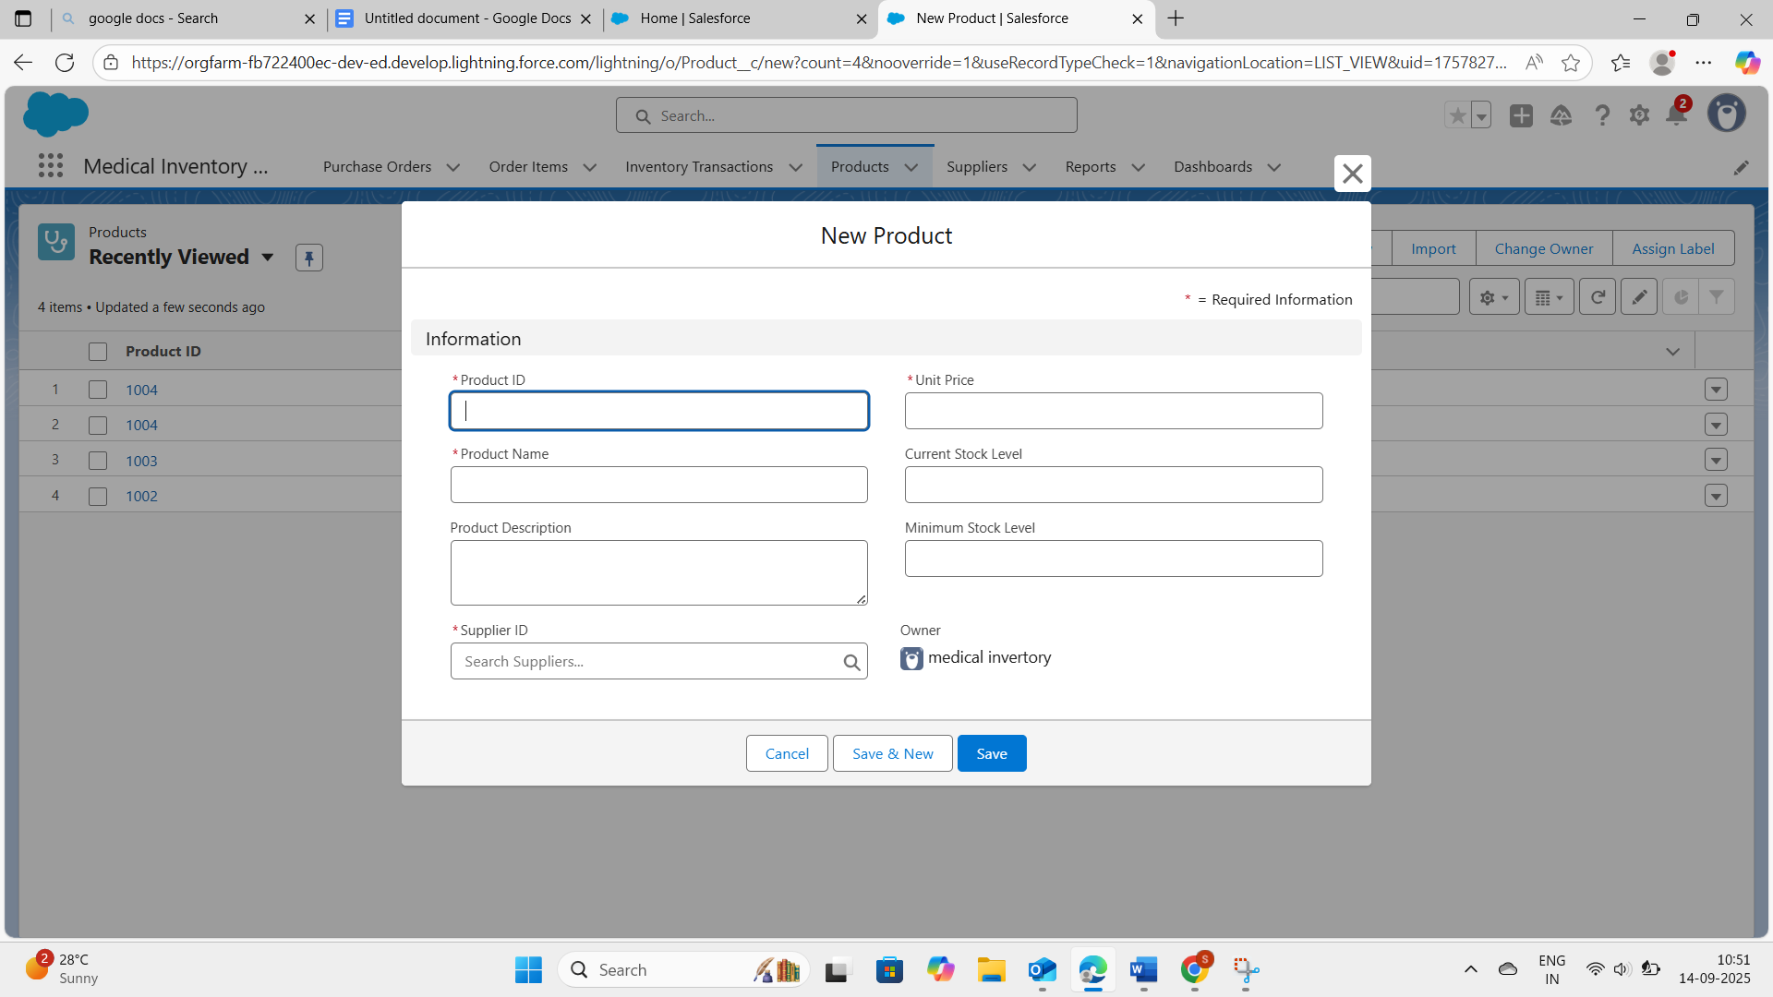

**5. Suppliers**

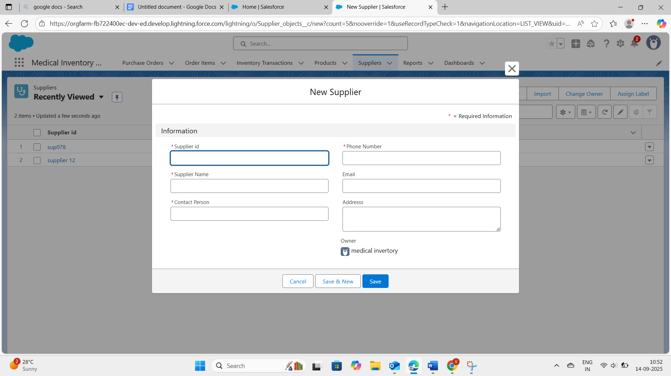

# **RESULTS**

# 

## **Output Screenshots**

**Reports output**

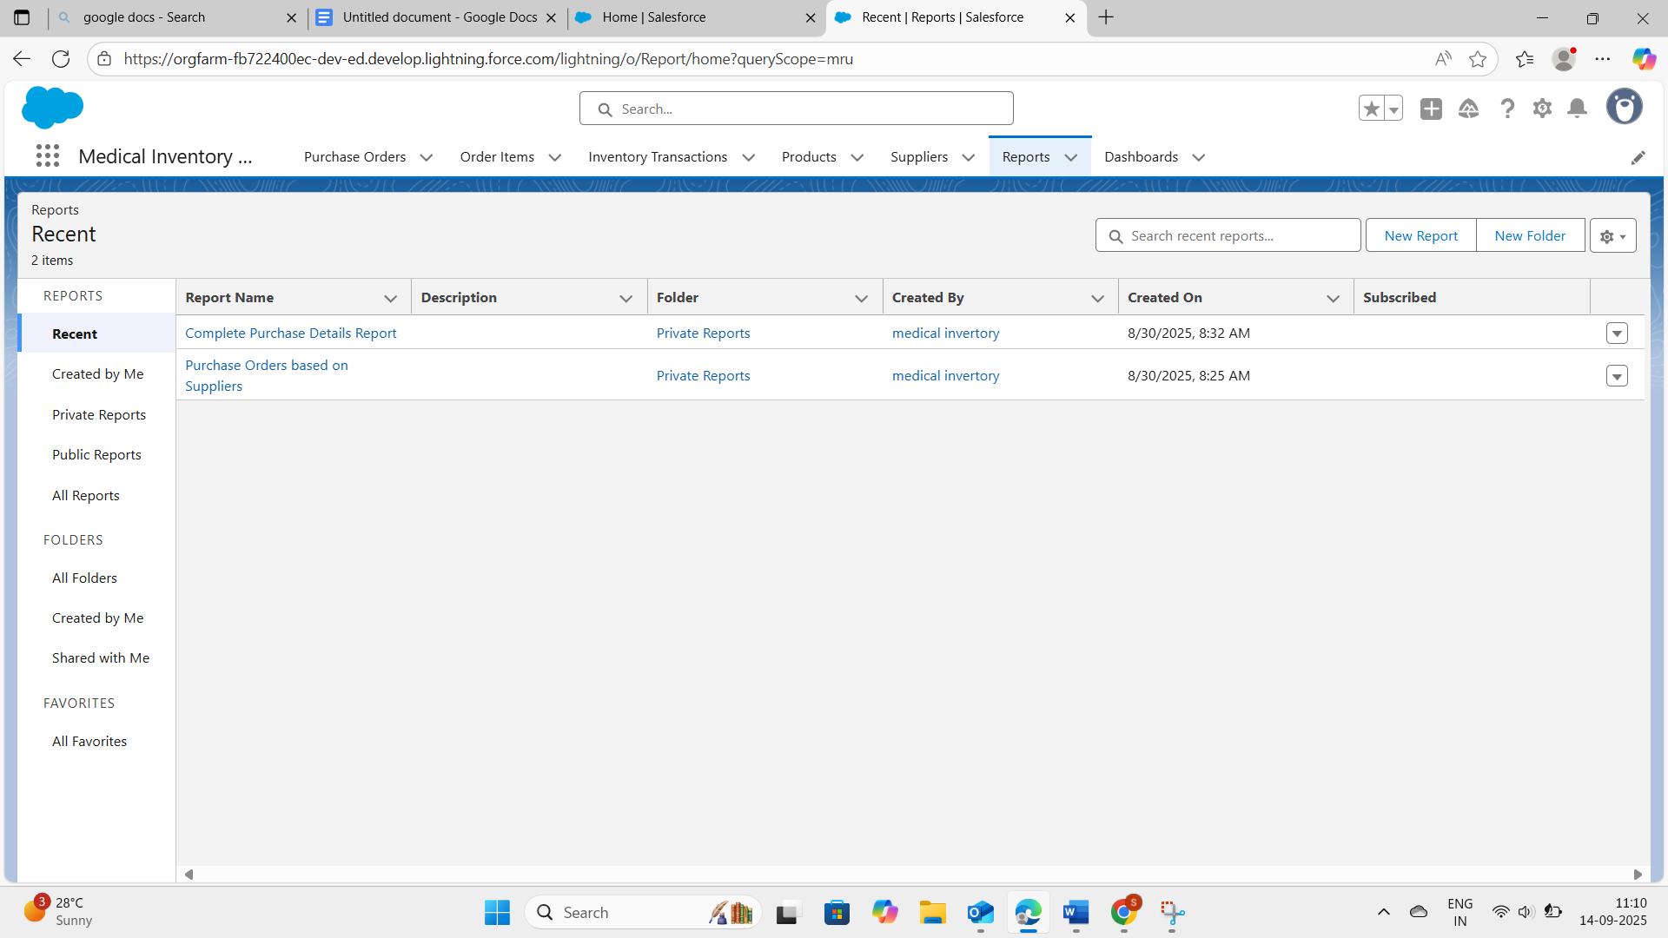

**Dashboard output**

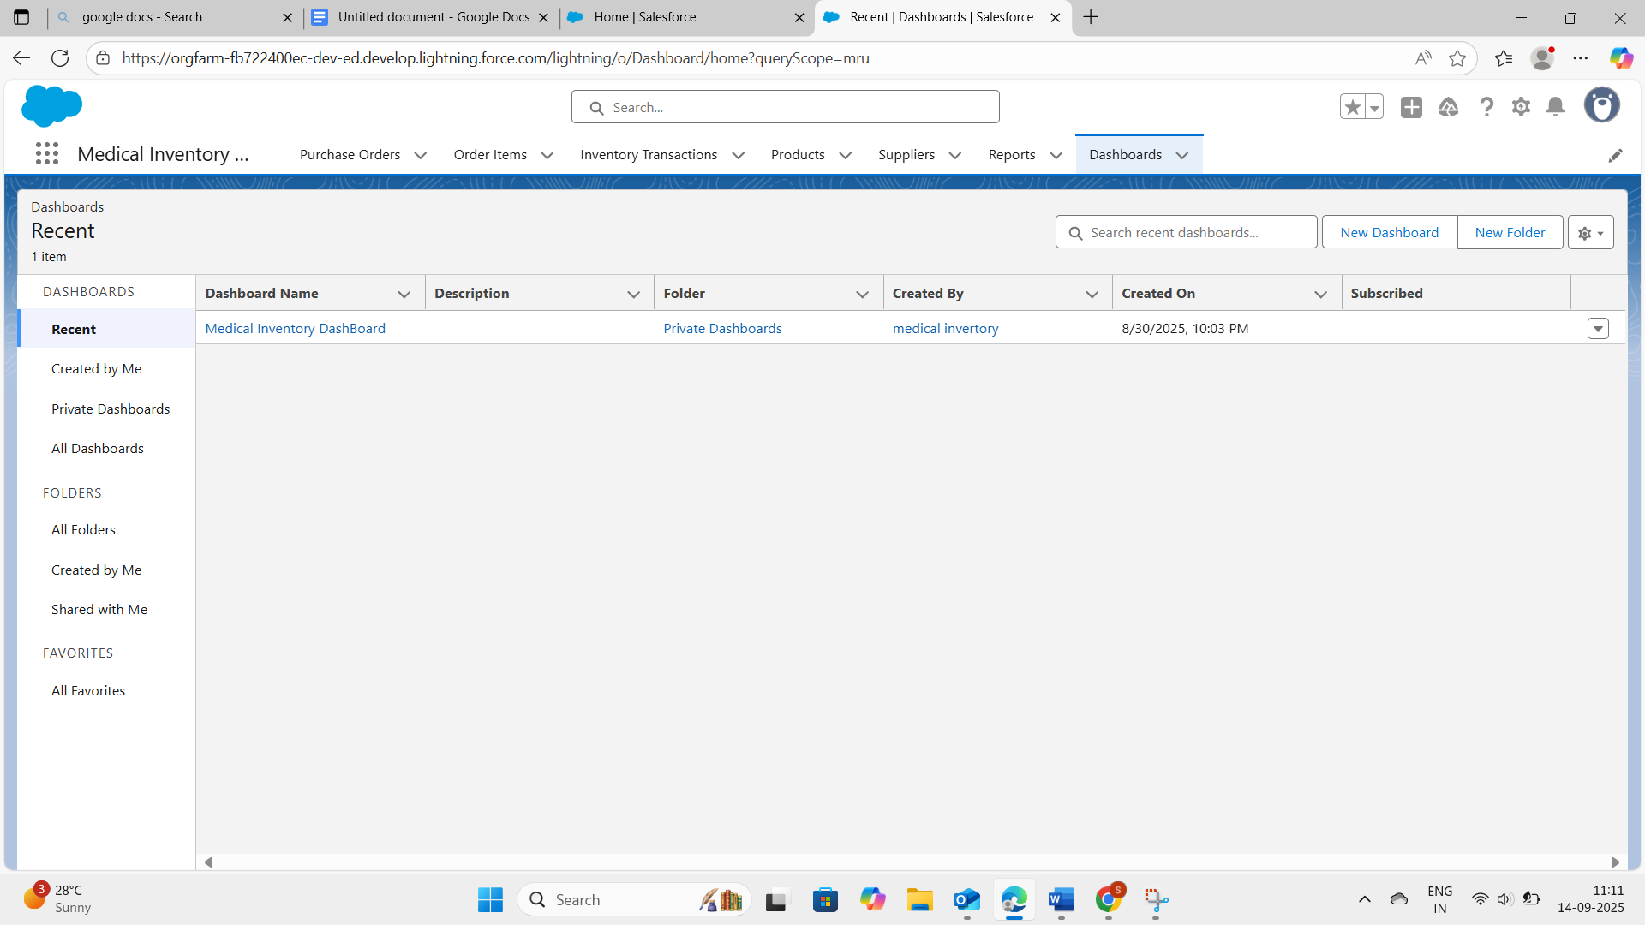



**ADVANTAGES & DISADVANTAGES**

**Advantages**

* The Medical Inventory Management System in Salesforce provides several benefits that improve efficiency, accuracy, and decision-making:
* Centralized System – All supplier, product, purchase order, and expiry details are managed in a single platform, reducing duplication and errors.
* Automation of Processes – Flows and triggers reduce manual work by automatically updating stock levels, sending expiry alerts, and managing orders.
* Improved Accuracy – Validation rules ensure correct data entry, preventing mistakes such as negative stock or invalid expiry dates.
* Enhanced Decision-Making – Managers can make data-driven decisions using trends and analytics provided by Salesforce.
* Scalability – The system can easily grow with the organization, supporting additional products, suppliers, or users without major changes.
* Data Security – With roles, profiles, and permission sets, access is controlled, ensuring sensitive data is secure.
* Better Compliance – By tracking expiry dates and stock, the system supports compliance with healthcare safety regulations.
* User-Friendly Interface – Lightning App and customized layouts make it easy for users to navigate and work efficiently.
* Cloud-Based Access – Being on Salesforce, the system is accessible from anywhere, enabling remote monitoring and management.

.

**Disadvantage**

1. Initial Setup Effort – Requires significant time to create objects, relationships, and automation in Salesforce.

2. Cost Factor – While the developer edition is free, real implementation in organizations may require paid Salesforce licenses.

3. Learning Curve – Users and admins need training to effectively use Salesforce features like flows, triggers, and dashboards.

4. Dependency on Internet – Since Salesforce is cloud-based, internet connectivity is mandatory.

**CONCLUSION**

The Medical Inventory Management System built on Salesforce provides a powerful, centralized solution to manage medical inventory efficiently. By integrating supplier management, purchase orders, product tracking, and expiry monitoring into one application, the system ensures accuracy, transparency, and reliability in day-to-day operations.

Through the use of custom objects, validation rules, automation (flows and triggers), and dashboards, the project demonstrates how Salesforce can be adapted for real-world healthcare challenges. The system not only streamlines processes but also enhances patient safety by preventing the use of expired products and supports better decision-making through real-time reporting and analytics.

Overall, this project highlights the importance of automation, data accuracy, and user-friendly design in modern medical inventory systems, and it showcases Salesforce as a robust platform for developing such critical business applications

## **APPENDIX**

* **Source Code: Provided in Apex Classes and Triggers**

public class CalculateTotalAmountHandler {

// Method to calculate the total amount for Purchase Orders based on related Order Items

public static void calculateTotal(List<Order_Item__c> newItems, List<Order_Item__c> oldItems, Boolean isInsert, Boolean isUpdate, Boolean isDelete, Boolean isUndelete) {

// Collect Purchase Order IDs affected by changes in Order_Item__c records

Set<Id> parentIds = new Set<Id>();

// For insert, update, and undelete scenarios

if (isInsert || isUpdate || isUndelete) {

for (Order_Item__c ordItem : newItems) {

parentIds.add(ordItem.Purchase_Order_Id__c);

}

}

// For update and delete scenarios

if (isUpdate || isDelete) {

for (Order_Item__c ordItem : oldItems) {

parentIds.add(ordItem.Purchase_Order_Id__c);

}

}

// Calculate the total amounts for affected Purchase Orders

Map<Id, Decimal> purchaseToUpdateMap = new Map<Id, Decimal>();

if (!parentIds.isEmpty()) {

// Perform an aggregate query to sum the Amount__c for each Purchase Order

List<AggregateResult> aggrList = [

SELECT Purchase_Order_Id__c, SUM(Amount__c) totalAmount

FROM Order_Item__c

WHERE Purchase_Order_Id__c IN :parentIds

GROUP BY Purchase_Order_Id__c

];

// Map the result to Purchase Order IDs

for (AggregateResult aggr : aggrList) {

Id purchaseOrderId = (Id)aggr.get('Purchase_Order_Id__c');

Decimal totalAmount = (Decimal)aggr.get('totalAmount');

purchaseToUpdateMap.put(purchaseOrderId, totalAmount);

}

// Prepare Purchase Order records for update

List<Purchase_Order__c> purchaseToUpdate = new List<Purchase_Order__c>();

for (Id purchaseOrderId : purchaseToUpdateMap.keySet()) {

Purchase_Order__c purchaseOrder = new Purchase_Order__c(Id = purchaseOrderId, Total_Order_cost__c = purchaseToUpdateMap.get(purchaseOrderId));

purchaseToUpdate.add(purchaseOrder);

}

// Update Purchase Orders if there are any changes

if (!purchaseToUpdate.isEmpty()) {

update purchaseToUpdate;

}

}

}

}